|  |  |
| --- | --- |
| Covid-19 (November 2023)  Data visualisation | Abstract  Summarized analysis with pictures, charts, and a dashboard about Coronavirus data from WHO. Only with 6 illustrations, it is clearly and fast understandable the effects and progress by the novel virus in the planet Earth.  YIT 19488399 (Tony)  Data Visualization - CMP020X302A Module Tutor: Mohammad Ahmad BSc Computer science, year 3rd (autumn term). |

**Task 1: questions that a visualization will answer.**

* From “vaccination data” dataset:

1. Number of different vaccines used by region and ALL countries that used 11 and 12 different types of vaccines.
2. Double bars plot about the speed and amount of vaccines administration to people in different countries (11 different countries in each bar plot).

* From “latest reported counts of cases and deaths” dataset:

1. Total number of deaths by country with top100 countries. Looks like BUBLES but code is SCATTER.
2. Total cases cumulative death by continent (region). Percentage information in each piece of the chart. PIE.
3. Confirmed cases per country and region by days (24 hours timeframe). MAP/INTERACTIVE MAP.

NOTES: each python code has at the beginning a commented link. This is the reference of the source of my code.

**Task 2: TABLEAU or POWER BI and follow instructions (one dashboard with five dynamic visualizations to analyze data).**

A dashboard with 8 worksheets, 1 picture and short text (2 references) to explain coronavirus data from WHO. Additional dataset used from official WHO website, plus dataset provided from module in Moodle. Datasets are recent, but not live updated.

All dashboard is interactive by region and country selection in the “Highlight” area. Selecting country anywhere in the dashboard will have same effects. Analysis and data visualization implemented in Tableau Public software and online because it is free to use and save the work can be done in the cloud (online).

First question: Number of different vaccines used by country or region

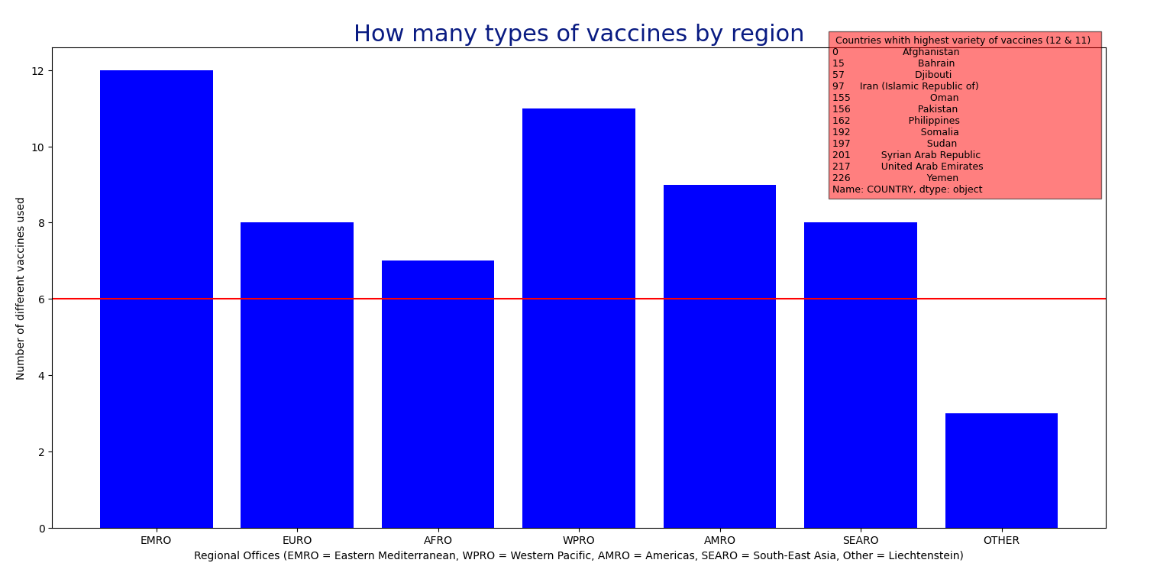

Output from running python code from VSC and screenshot. Both images are same data visualization, but different formats.

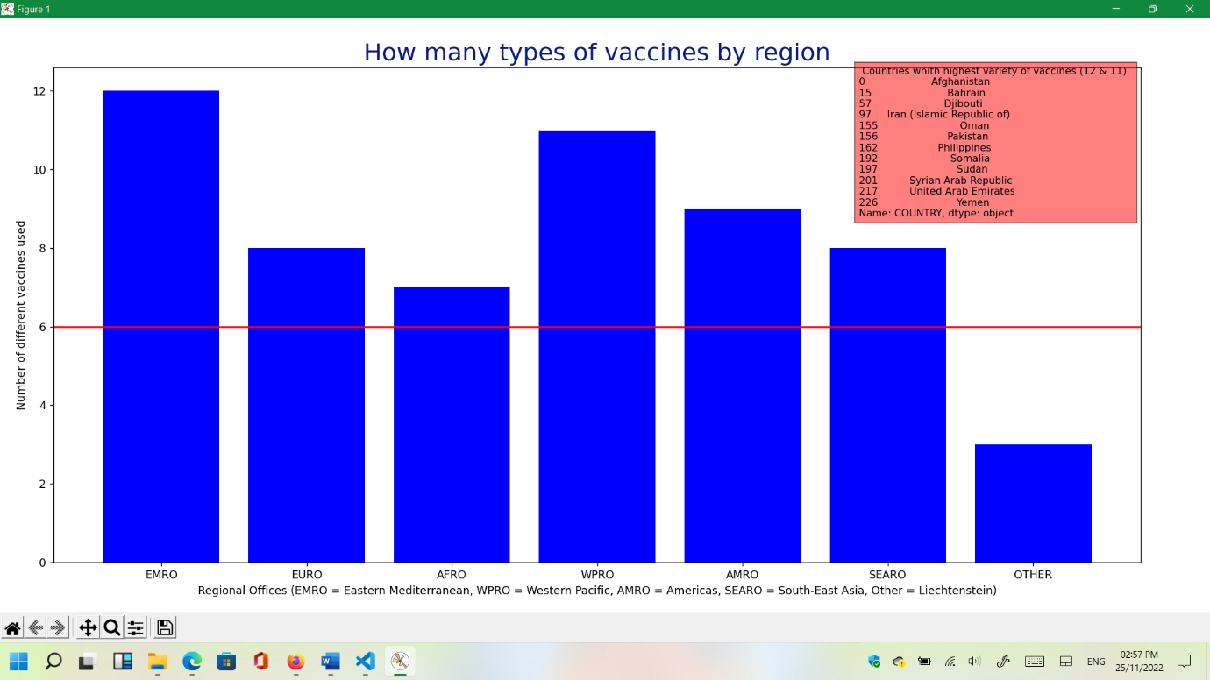

Python code follows with screenshot included. In this occasion, code output gives some information on terminal for familiarize with data (.csv):

import pandas as pd

import matplotlib.pyplot as plt

import numpy as np

data = pd.read_csv("vaccination-data.csv") #reading the database

print(data.head(), data.columns)

integer_vaccines_type = data["NUMBER_VACCINES_TYPES_USED"]

integer_vaccines_type.fillna(0)

print(integer_vaccines_type, len(integer_vaccines_type), integer_vaccines_type.unique())

region = data["WHO_REGION"]

print(region, len(region), region.unique())

# print(max(data["NUMBER_VACCINES_TYPES_USED"]))

print(data['NUMBER_VACCINES_TYPES_USED'].nlargest(n=12)) #untill 11 inclusive

print(data.loc[data['NUMBER_VACCINES_TYPES_USED']>10, 'COUNTRY'])

top_variety = data.loc[data['NUMBER_VACCINES_TYPES_USED']>10, 'COUNTRY']

print(top_variety, len(top_variety))

top_varietylist = np.array(top_variety)

fig, axe = plt.subplots(figsize=(14, 7))

plt.bar(data["WHO_REGION"], data["NUMBER_VACCINES_TYPES_USED"], color = "blue")

plt.xlabel('Regional Offices (EMRO = Eastern Mediterranean, WPRO = Western Pacific, AMRO = Americas, SEARO = South-East Asia, Other = Liechtenstein)')

plt.ylabel('Number of different vaccines used')

plt.title("How many types of vaccines by region", color = "#091b82", fontsize = 22)

plt.axhline(y = 6, color = 'r', linestyle = '-')

axe.text(4.8, 8.8, f" Countries whith highest variety of vaccines (12 & 11)  \n{top_variety}", bbox=dict(facecolor='red', alpha=0.5),fontsize = 9)

plt.tight_layout(pad=1.1, w_pad=0.5, h_pad=0.2)

plt.show()

fig.savefig("output1.png")

plt.close(fig)

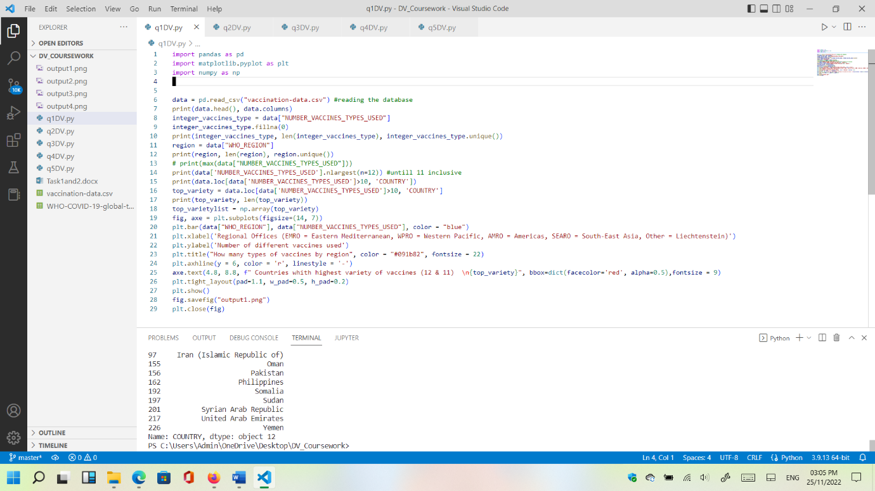

Second question: Which countries started vaccinations first (speed) and which countries has the highest amount of vaccinated people?

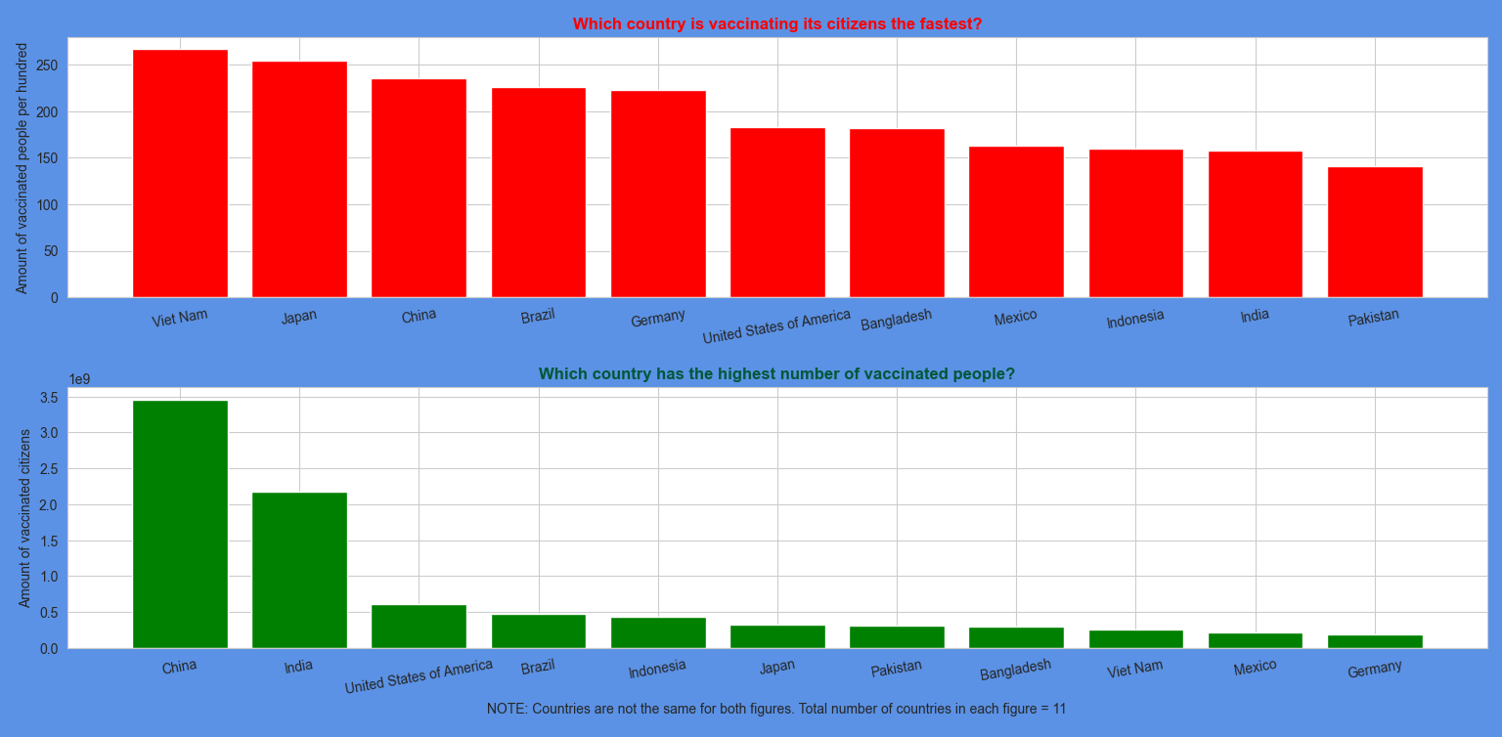

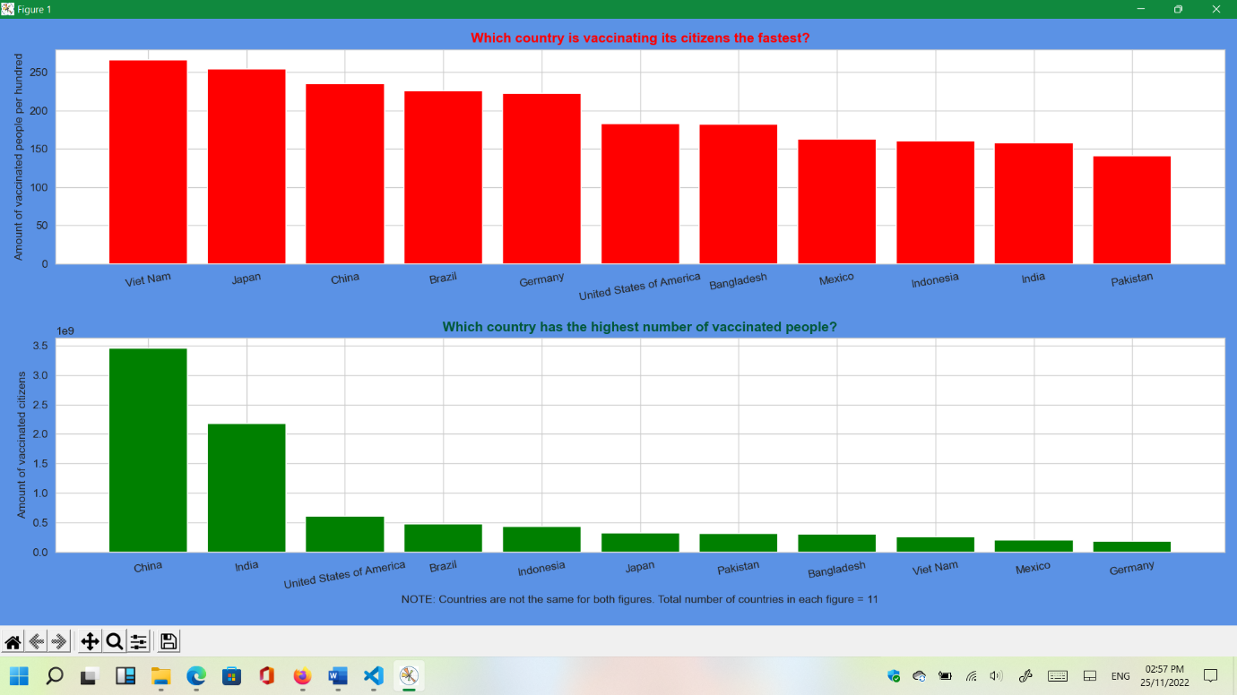

# https://towardsdatascience.com/covid-19-vaccination-progress-analysis-around-the-world-736d7e57f198

import matplotlib.pyplot as plt

import seaborn as sns

import pandas as pd

sns.set_style('whitegrid')

df = pd.read_csv("vaccination-data.csv")

plt.figure(1, figsize=(15, 7),facecolor="#5b92e5")

plt.subplot(211)

cols = ['COUNTRY', 'TOTAL_VACCINATIONS', 'ISO3', 'VACCINES_USED','TOTAL_VACCINATIONS_PER100']

vacc_amount = df[cols].groupby('COUNTRY').max().sort_values('TOTAL_VACCINATIONS', ascending=False).dropna(subset=['TOTAL_VACCINATIONS'])

vacc_amount = vacc_amount.iloc[:11]

vacc_amount = vacc_amount.sort_values('TOTAL_VACCINATIONS_PER100', ascending=False)

plt.bar(vacc_amount.index, vacc_amount.TOTAL_VACCINATIONS_PER100, color = 'r')

plt.xticks(rotation = 10)

plt.title("Which country is vaccinating its citizens the fastest?", color = "r", fontweight="bold")

plt.ylabel('Amount of vaccinated people per hundred')

plt.subplot(212)

cols = ['COUNTRY', 'TOTAL_VACCINATIONS', 'ISO3', 'VACCINES_USED']

vacc_amount = df[cols].groupby('COUNTRY').max().sort_values('TOTAL_VACCINATIONS', ascending=False).dropna(subset=['TOTAL_VACCINATIONS'])

vacc_amount = vacc_amount.iloc[:11]

plt.bar(vacc_amount.index, vacc_amount.TOTAL_VACCINATIONS, color = 'g')

plt.title('Which country has the highest number of vaccinated people?', color ="#025839", fontweight="bold")

plt.ylabel('Amount of vaccinated citizens')

plt.xlabel('NOTE: Countries are not the same for both figures. Total number of countries in each figure = 11')

plt.xticks(rotation = 10)

plt.tight_layout()

plt.show()

plt.savefig("output2.png")

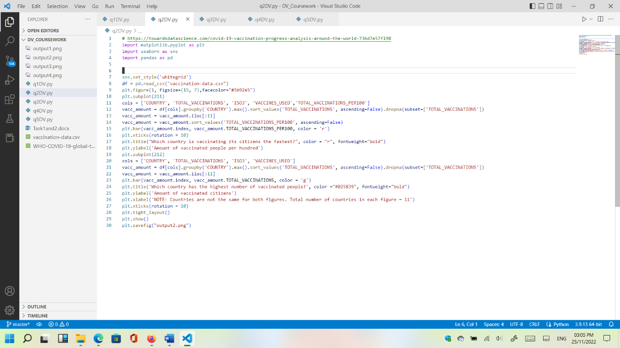

Third question: Cumulative deaths grouped by countries and showing only top 100 countries (total countries are 237):

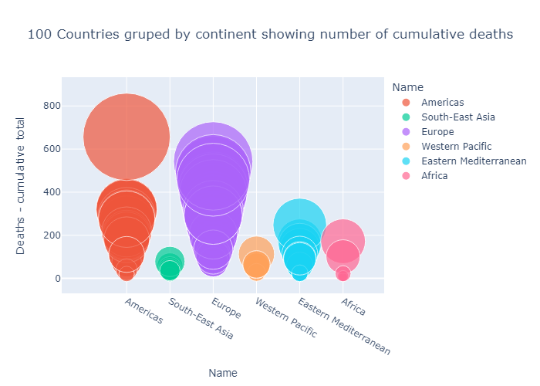

First image is the output that generates python code from VSC editor and saved using plotly buttons (top right). Second and third are screenshots of same picture.

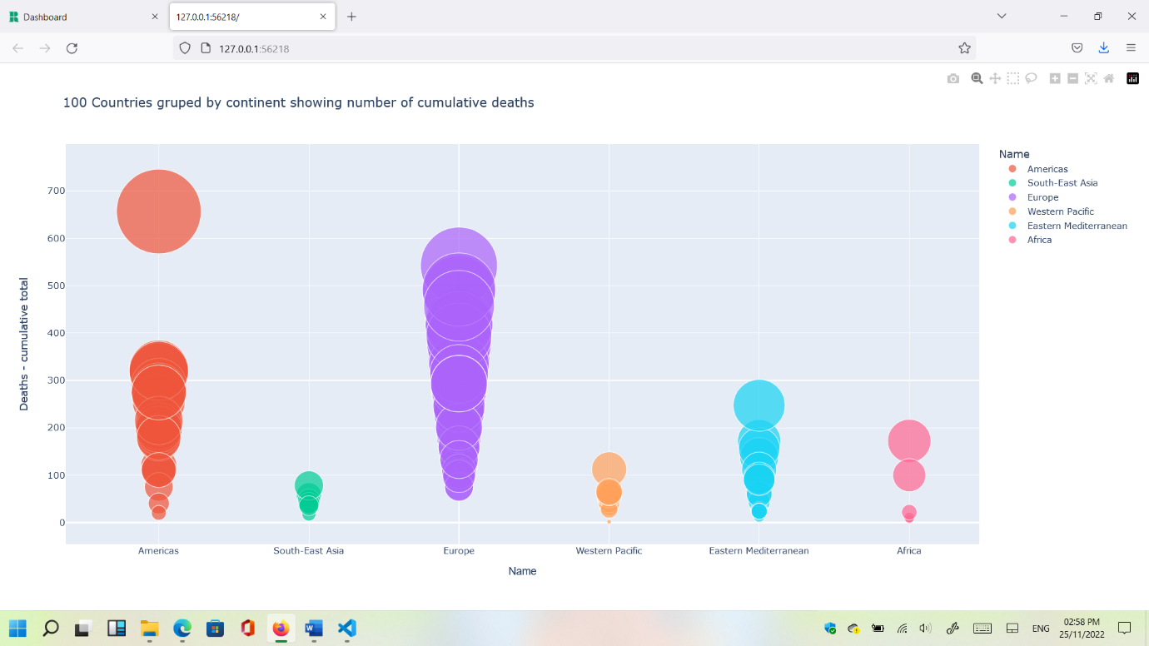

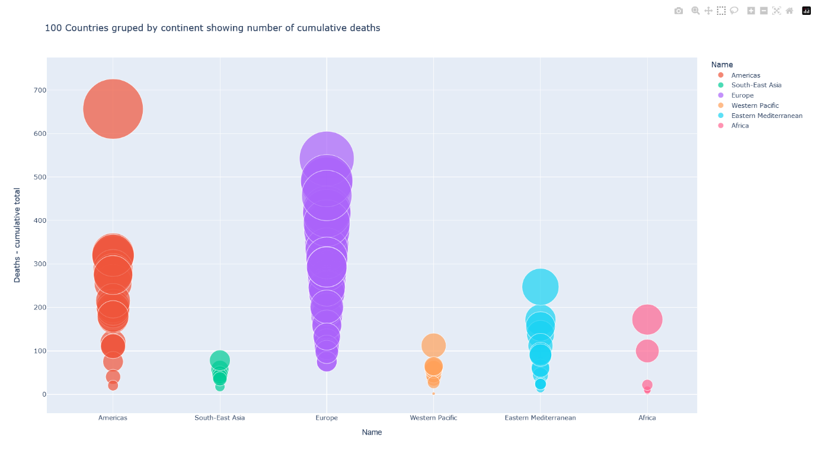

#https://www.geeksforgeeks.org/covid-19-analysis-and-visualization-using-plotly-express/

import plotly.express as px

import pandas as pd

import plotly.io as pio

df = pd.read_csv("WHO-COVID-19-global-table-data.csv")

figure3 = px.scatter(df.head(100), x='Name', y= 'Deaths - cumulative total',

        hover_data=['WHO Region'],

        color='Name', size= 'Deaths - cumulative total', size_max=80, hover_name="Name",

        title=("100 Countries gruped by continent showing number of cumulative deaths"))

figure3.update_xaxes(title_font_family="Helvetica")

figure3.show()

# export as static image

pio.write_image(figure3, "output3.png")

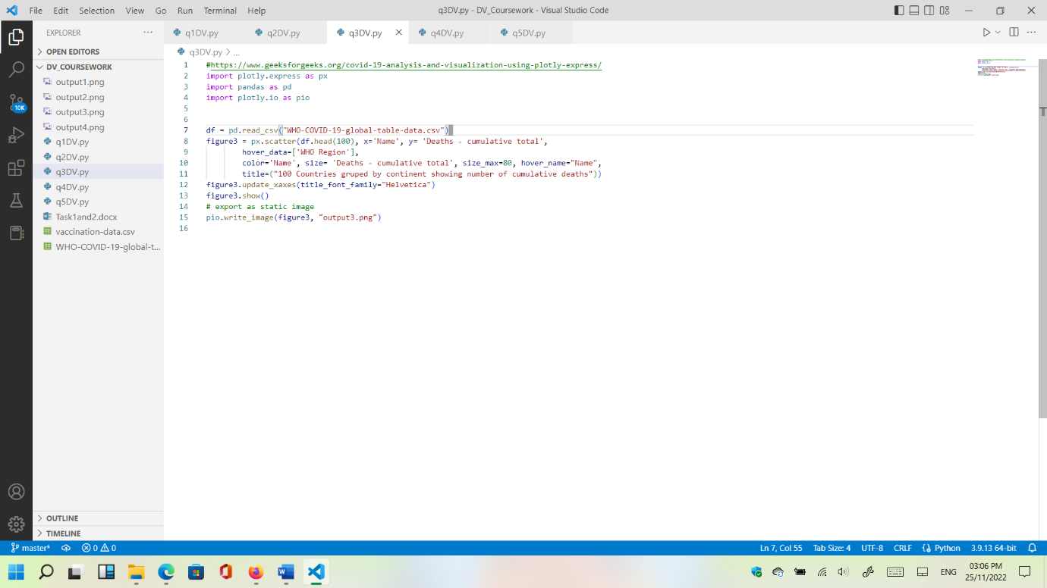

Fourth question: Total cumulative deaths grouped by continent using ALL countries. Pie chart.

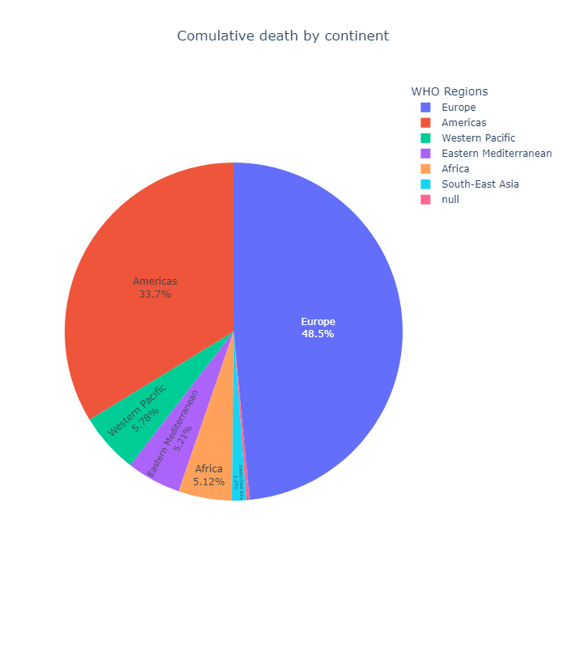

First picture is the output saved using top right button implemented in plotly. This picture is from VSC editor, using python programming language.

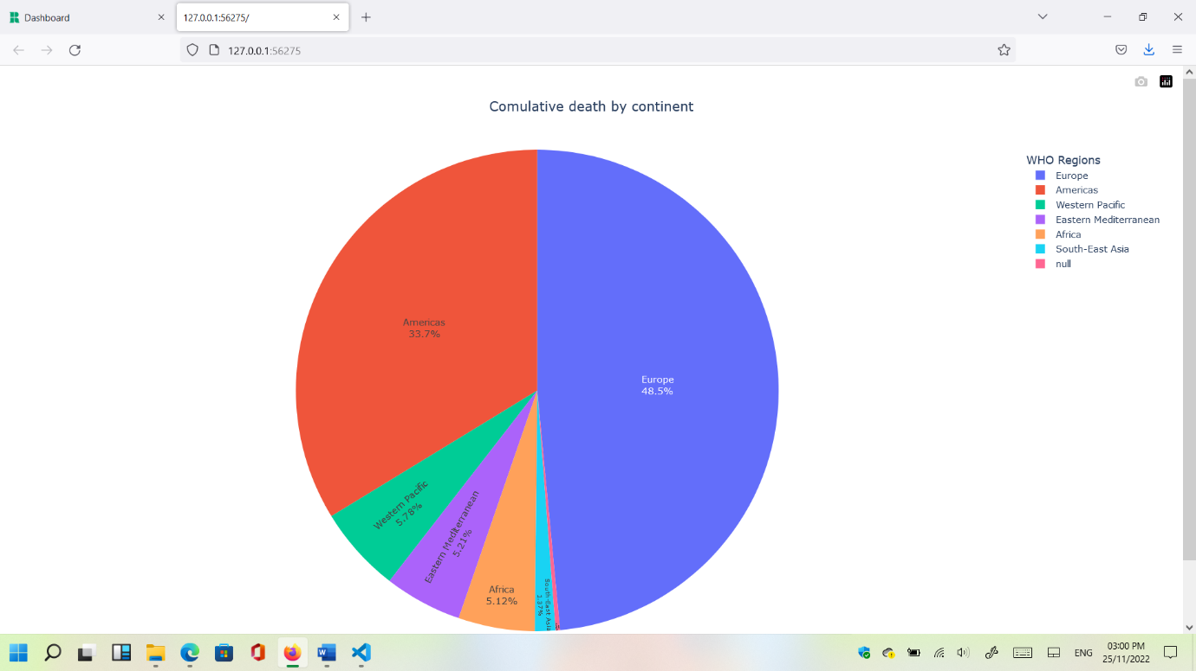

Both images are screenshots from previous initial image. Browser is used (Firefox). The third and last image is a full screen on the image on the browser (2nd).

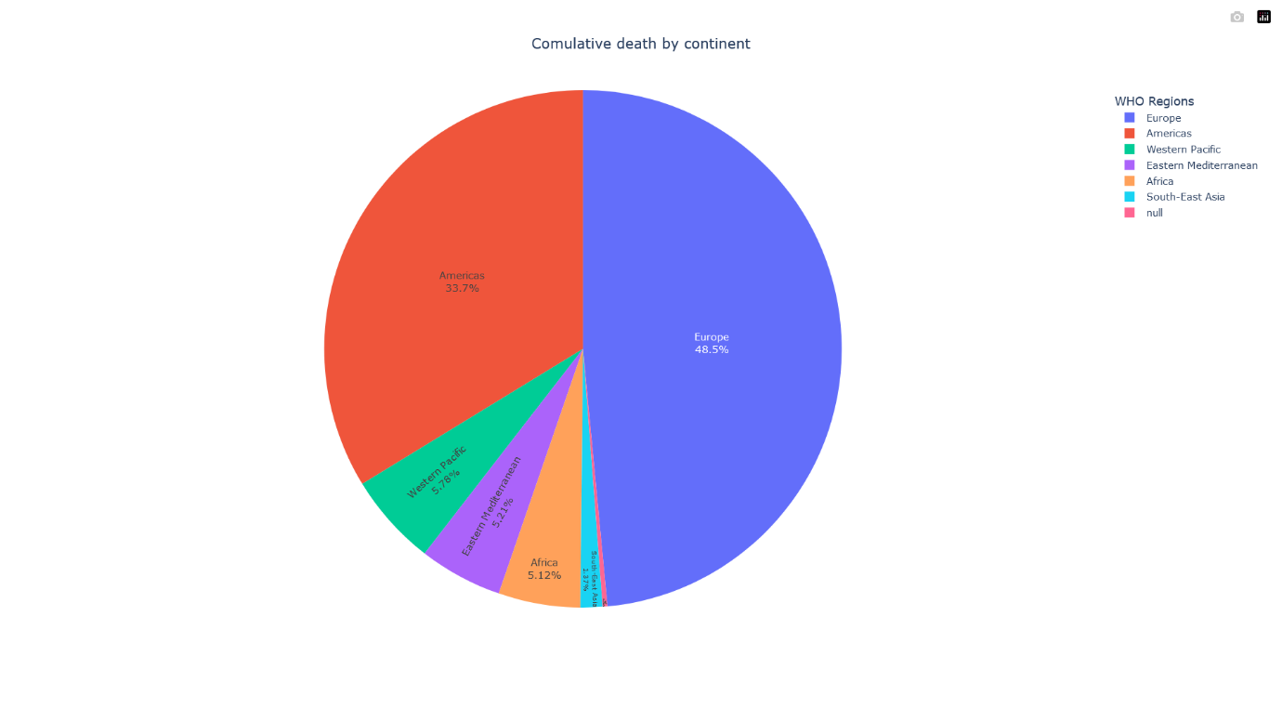

# https://www.kaggle.com/code/siddheshmahajan/covid-19-data-visualization

import pandas as pd

import plotly.io as pio

import plotly.express as px

df = pd.read_csv("WHO-COVID-19-global-table-data.csv")

df_countries = df.groupby(['WHO Region']).max().reset_index()

df_countries = df_countries.drop_duplicates(subset = ['WHO Region'])

#the classic pie chart

fig = px.pie(df_countries, values = 'Deaths - cumulative total', names='Name', height=800, title='Comulative death by continent')

fig.update_traces(textposition='inside', textinfo='percent+label')

fig.update_layout(

    title_x = 0.5,

    autosize = True,

    geo=dict(

        showframe = False,

        showcoastlines = False,

    ))

fig.update_layout(legend=dict(

    title="WHO Regions"

)) # write a title for the legend on the right

fig.show()

pio.write_image(fig, "output4.png")

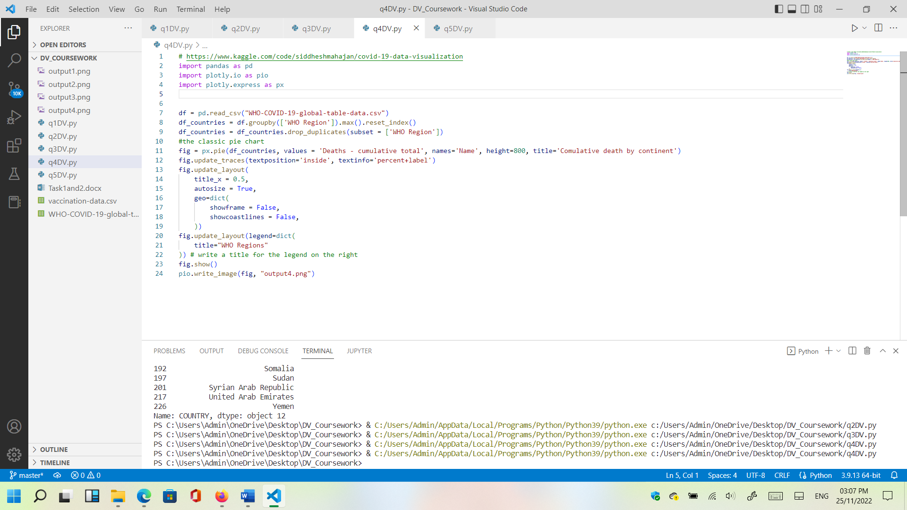

Fifth question: Animated visualization of the spread of the coronavirus. Updates by day (24 hours).

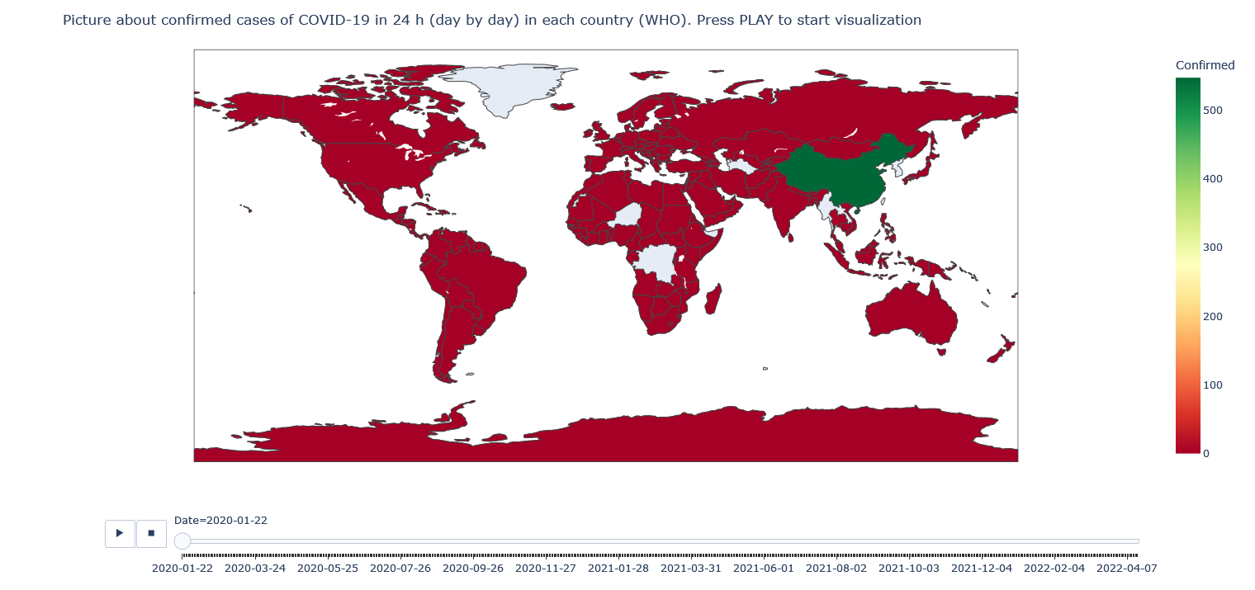

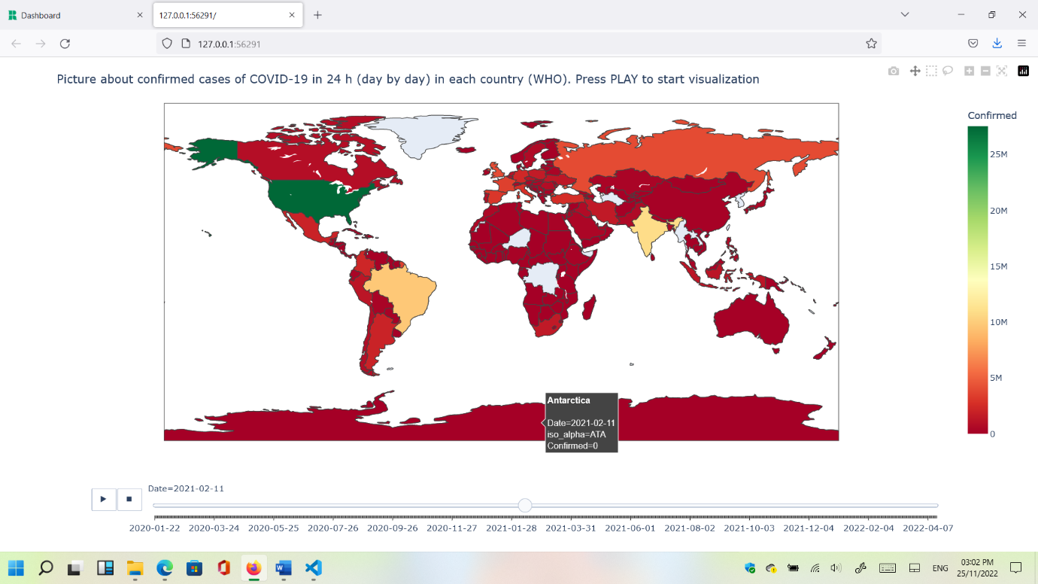

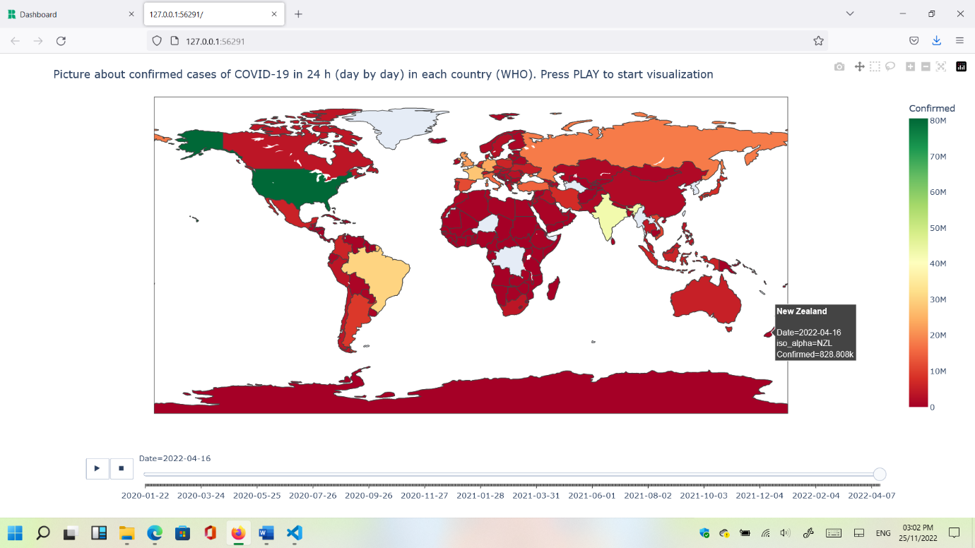

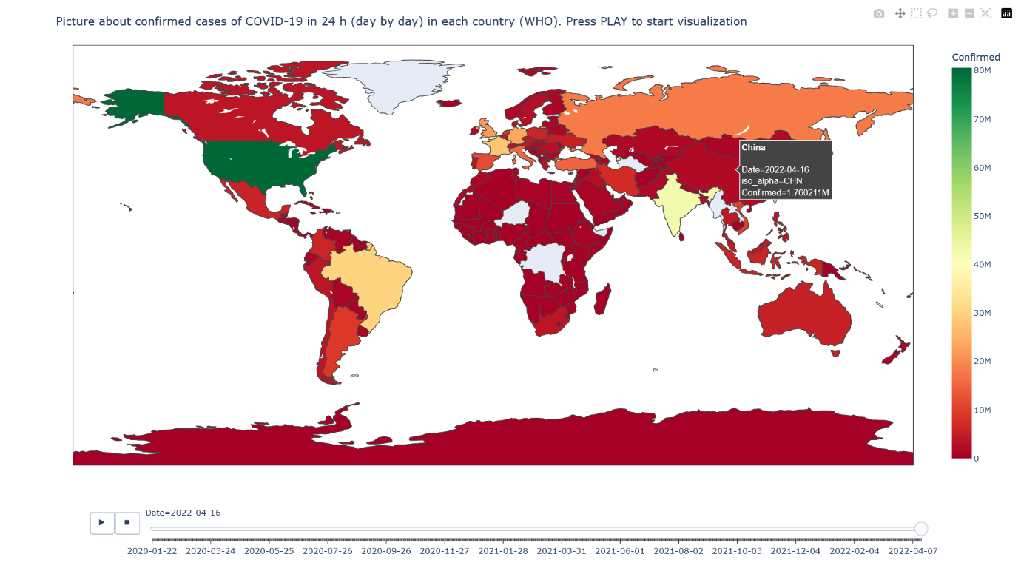

# https://www.kaggle.com/code/lokeshrth4617/covid-19-world-wise-visualization

# https://opensource.com/article/20/4/python-map-covid-19

import pycountry

import plotly.express as px

import pandas as pd

# ----------- Step 1 ------------

URL_DATASET = r'https://raw.githubusercontent.com/datasets/covid-19/master/data/countries-aggregated.csv'

df1 = pd.read_csv(URL_DATASET)

# print(df1.head) # Uncomment to see what the dataframe is like

# ----------- Step 2 ------------

list_countries = df1['Country'].unique().tolist()

# print(list_countries) # Uncomment to see list of countries

d_country_code = {}  # To hold the country names and their ISO

for country in list_countries:

    try:

        country_data = pycountry.countries.search_fuzzy(country)

        # country_data is a list of objects of class pycountry.db.Country

        # The first item  ie at index 0 of list is best fit object of class Country have an alpha_3 attribute

        country_code = country_data[0].alpha_3

        d_country_code.update({country: country_code})

    except:

        print('could not add ISO 3 code for ->', country)

        d_country_code.update({country: ' '}) # If could not find country, make ISO code ' '

# print(d_country_code) # Uncomment to check dictionary

# create a new column iso_alpha in the df and fill it with appropriate iso 3 code

for k, v in d_country_code.items():

    df1.loc[(df1.Country == k), 'iso_alpha'] = v

# print(df1.head)  # Uncomment to confirm that ISO codes added

# ----------- Step 3 ------------

fig = px.choropleth(data_frame = df1,

                    locations= "iso_alpha",

                    color= "Confirmed",  # value in column 'Confirmed' determines color

                    hover_name= "Country",

                    color_continuous_scale= 'RdYlGn',  #  color scale red, yellow green

                    animation_frame= "Date")

fig.update_layout(title="Picture about confirmed cases of COVID-19 in 24 h (day by day) in each country (WHO). Press PLAY to start visualization")

fig.show()

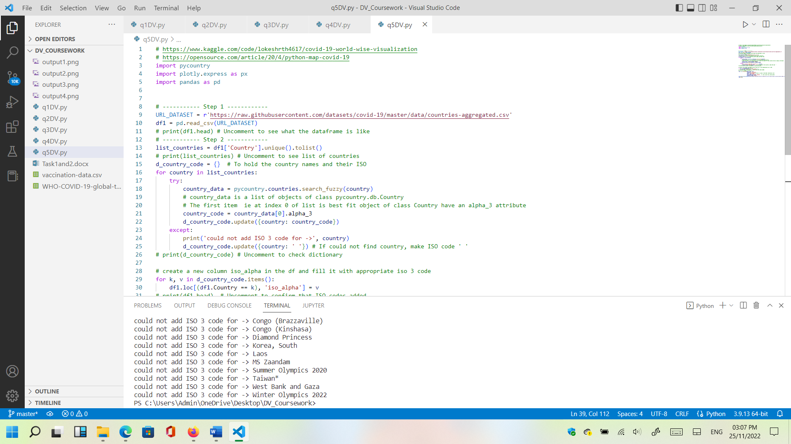

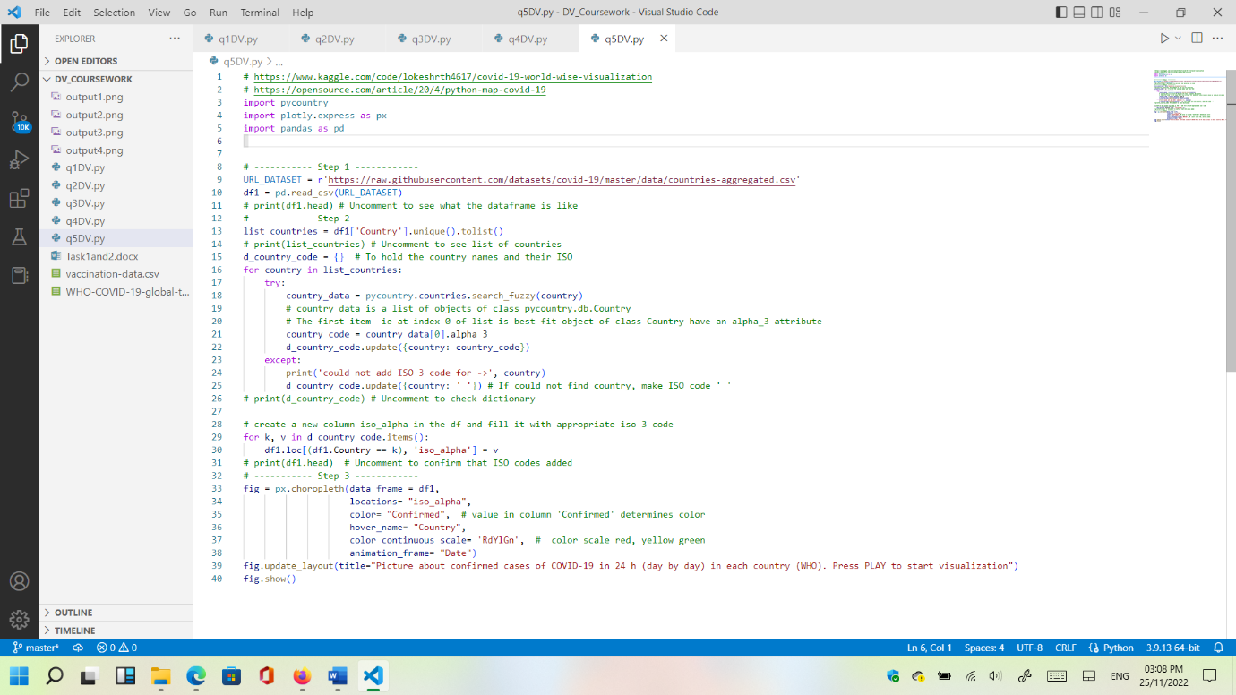

**Code on my GitHub:** [**https://github.com/ittonycash/data_visualisation/tree/main/coursework**](https://github.com/ittonycash/data_visualisation/tree/main/coursework)

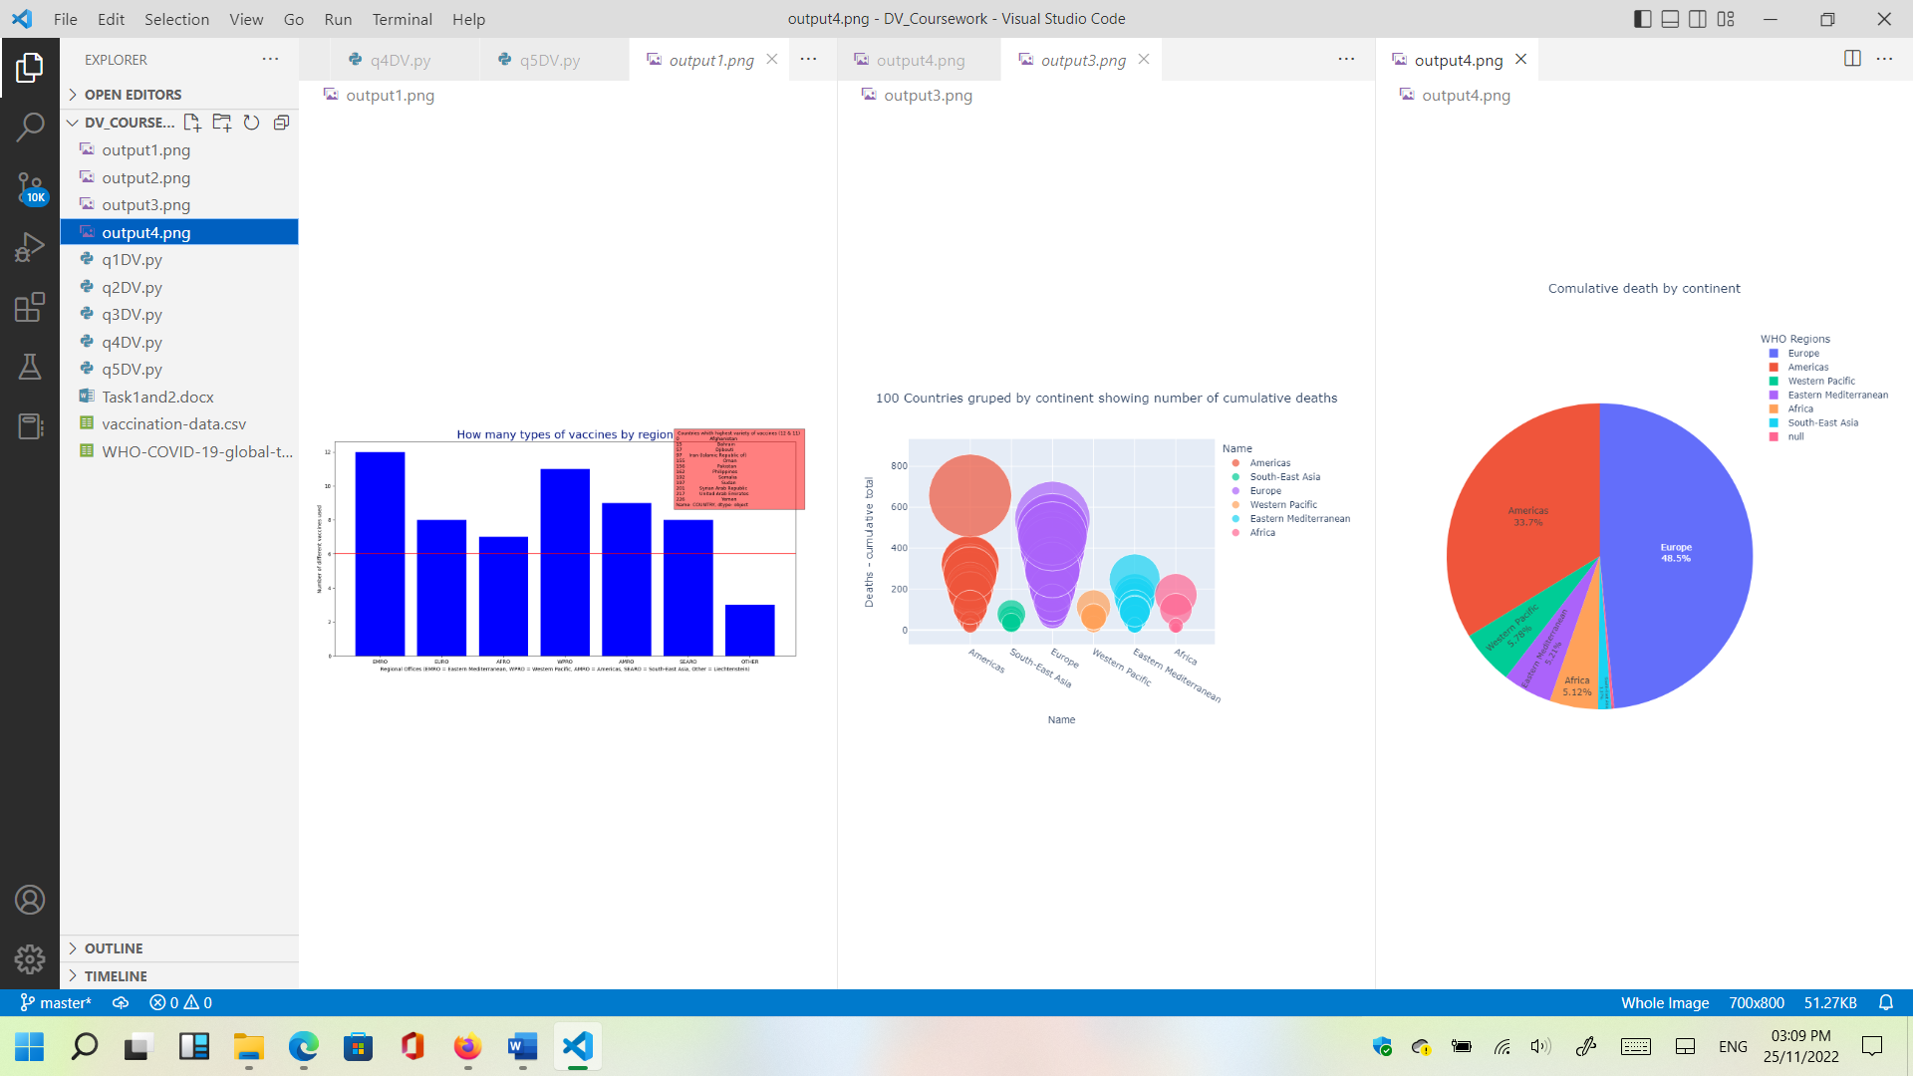

My audience:



**Task 2 screenshots. Individual sheets and final dashboard:**

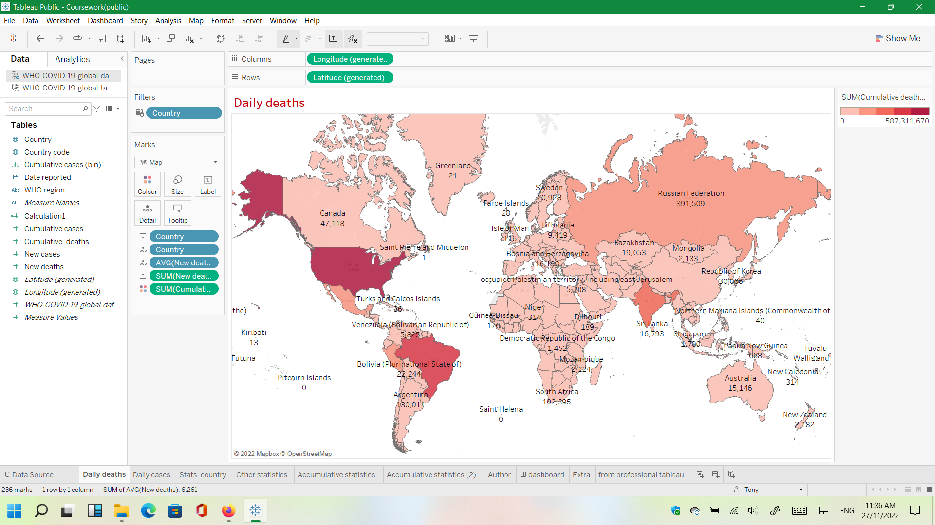

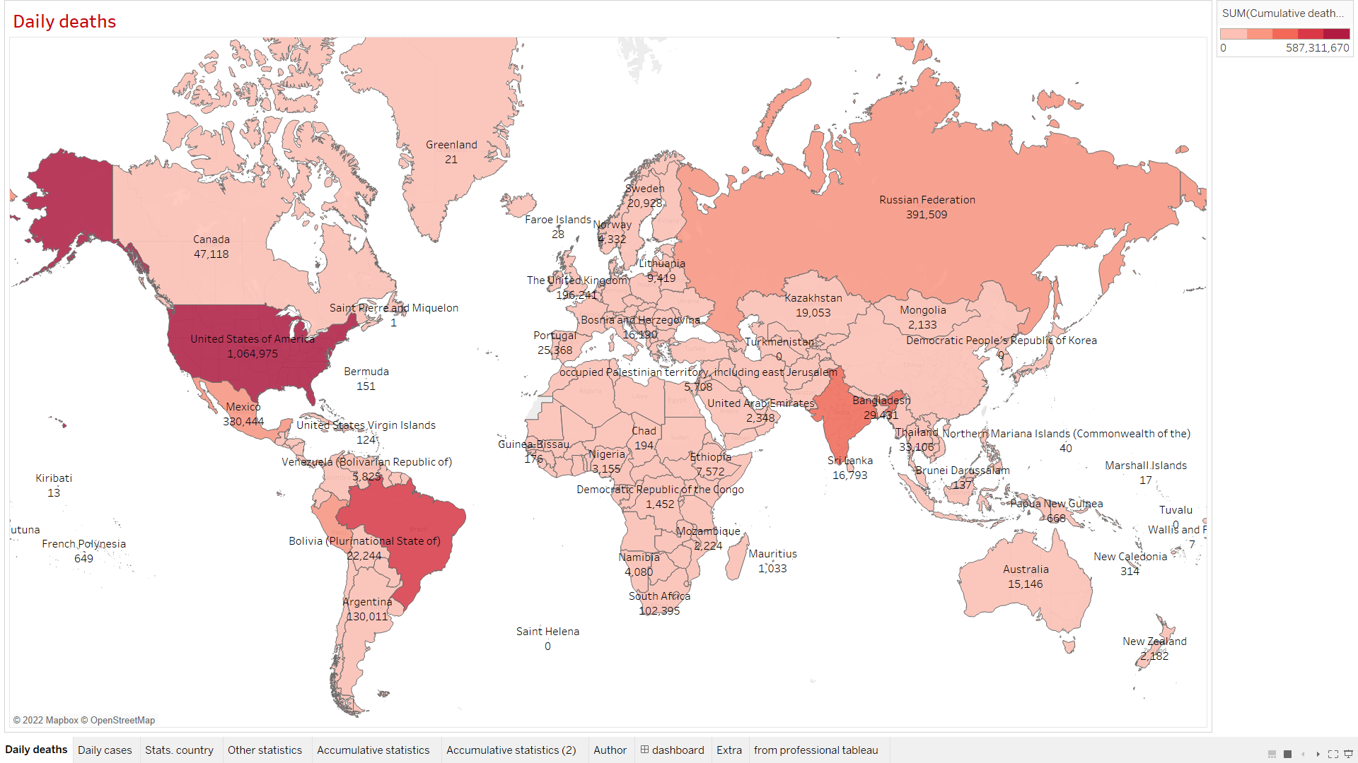

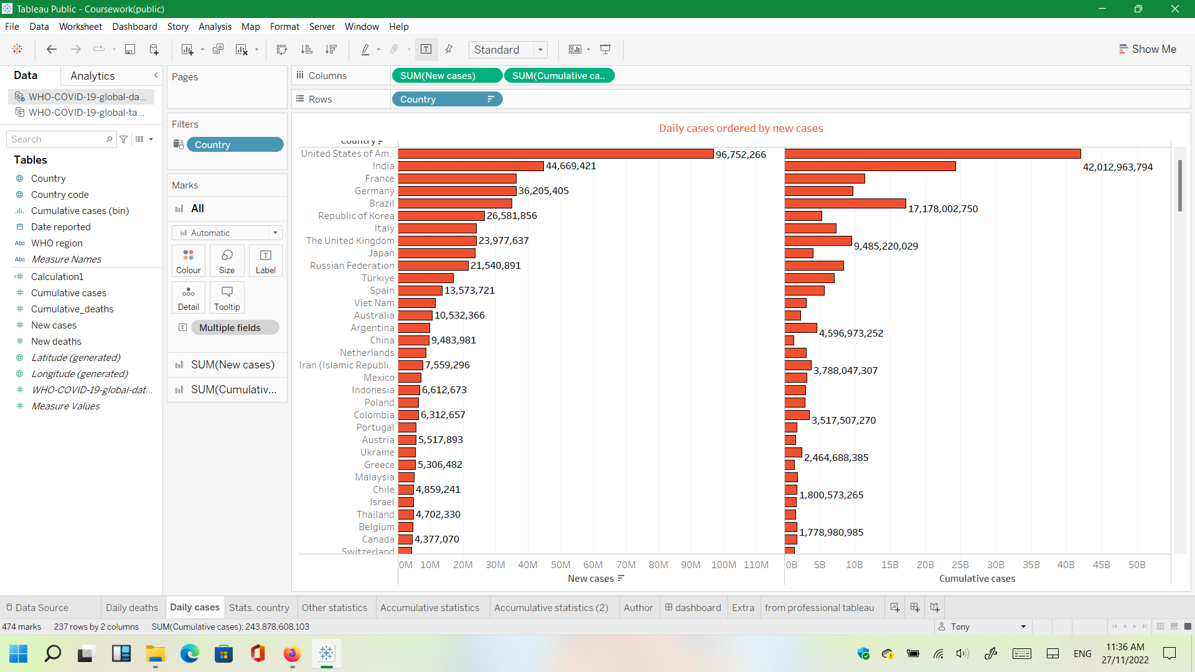

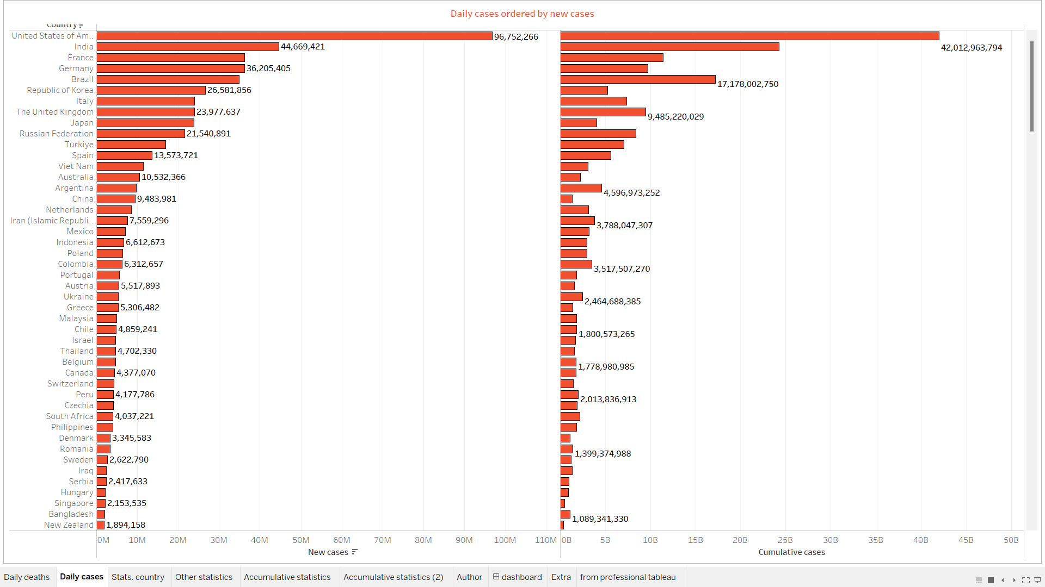

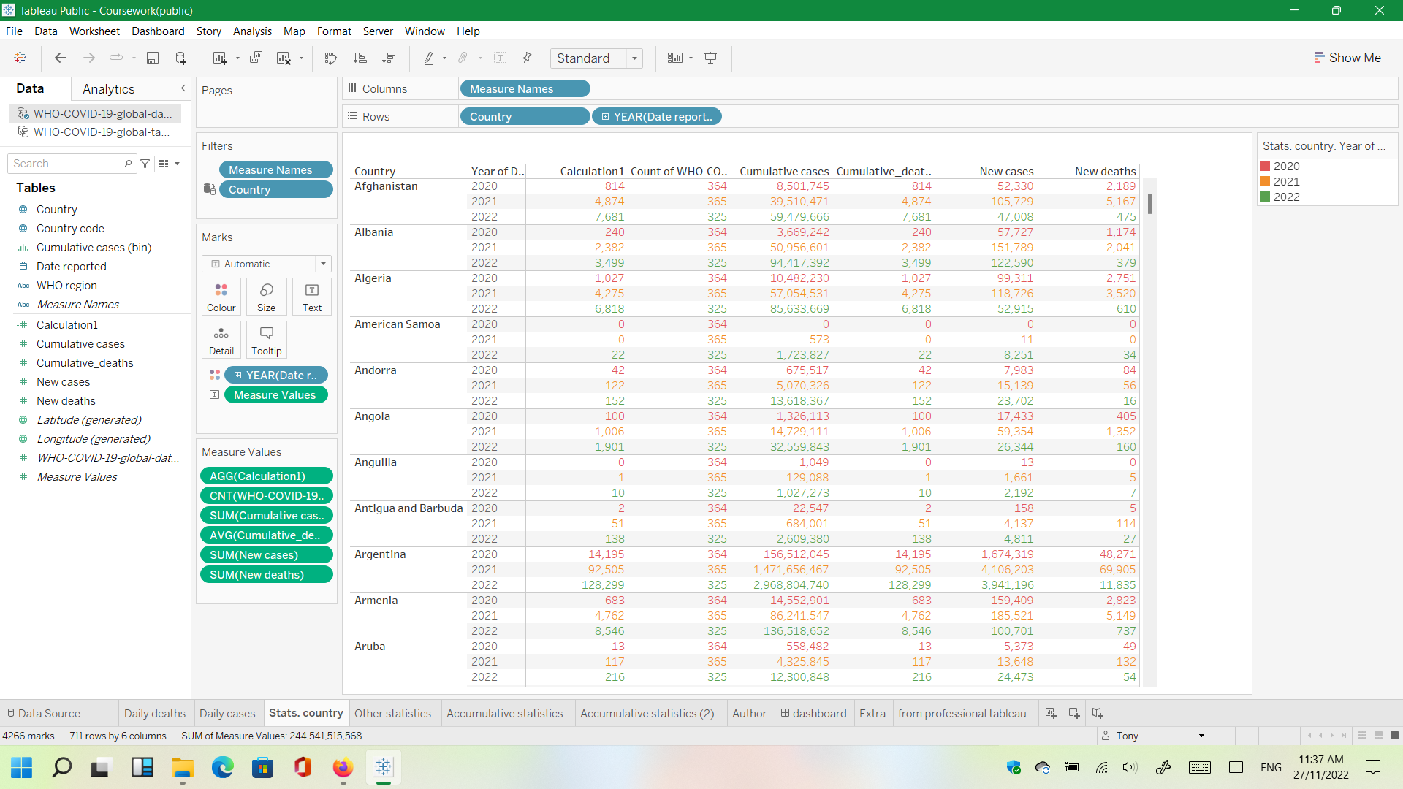

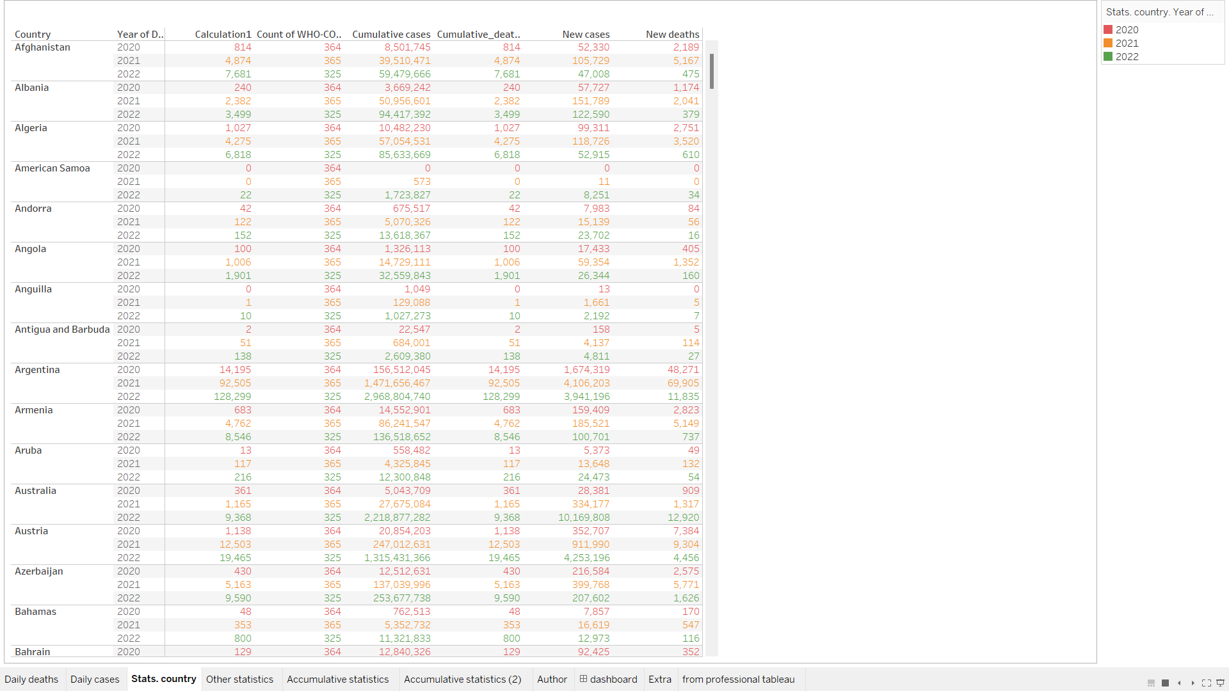

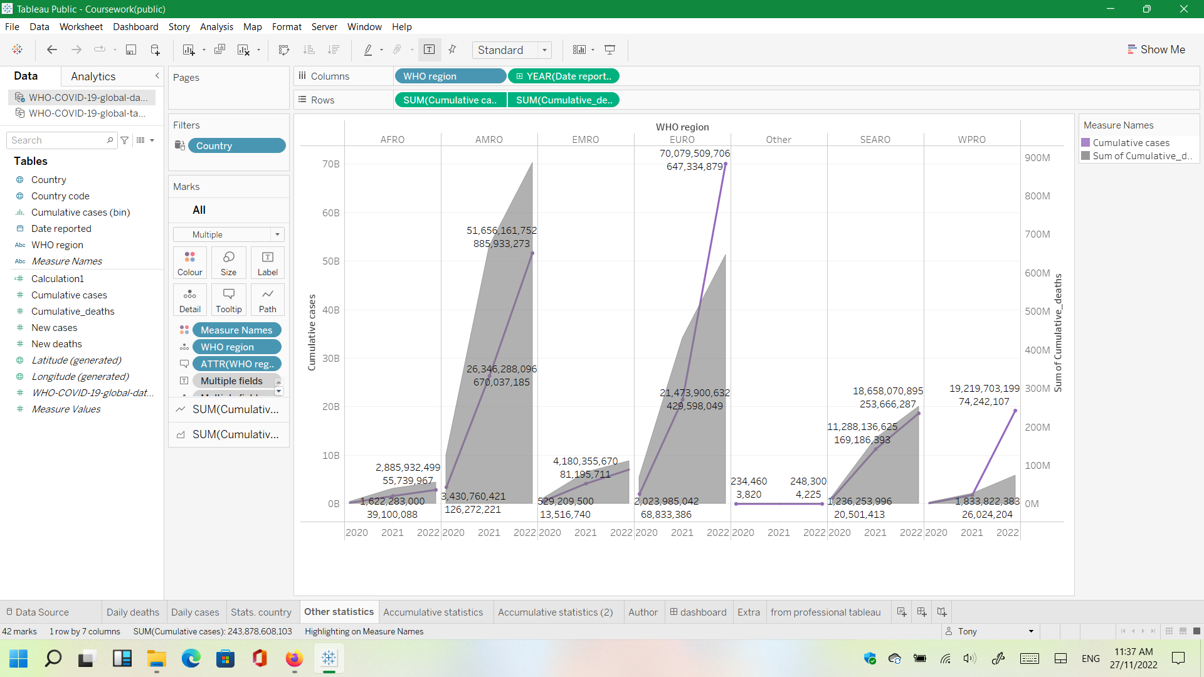

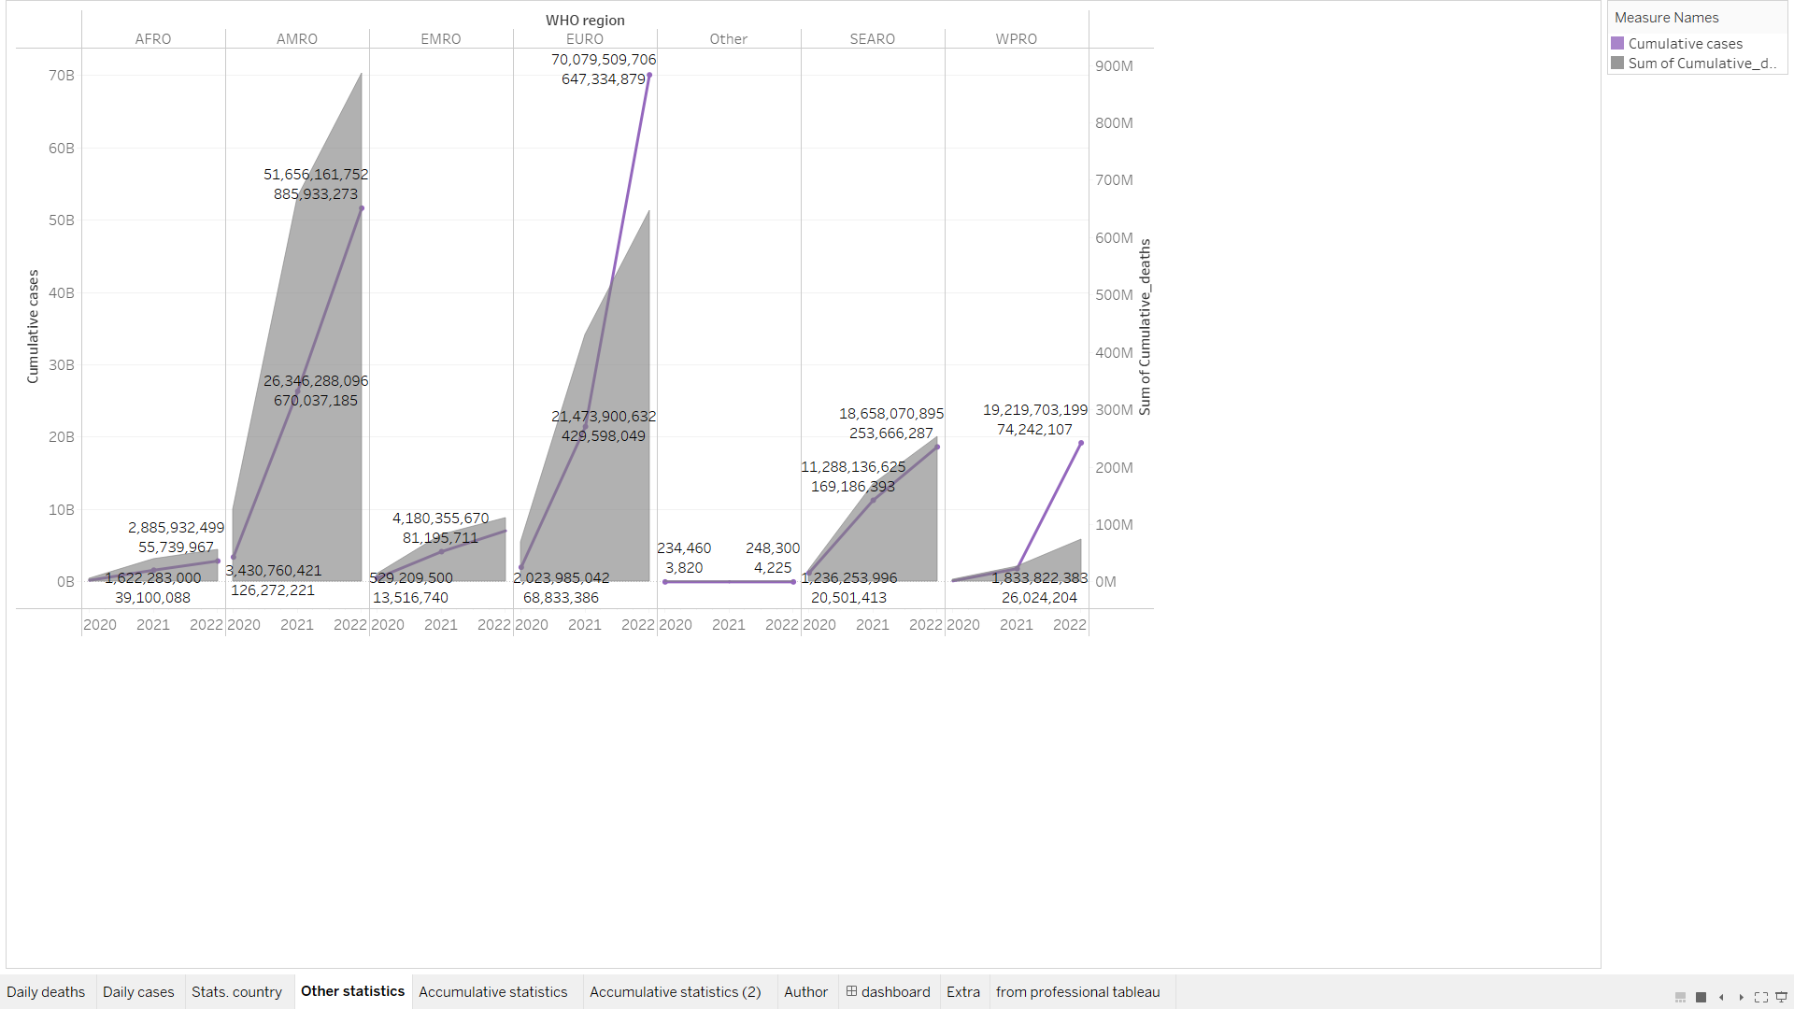

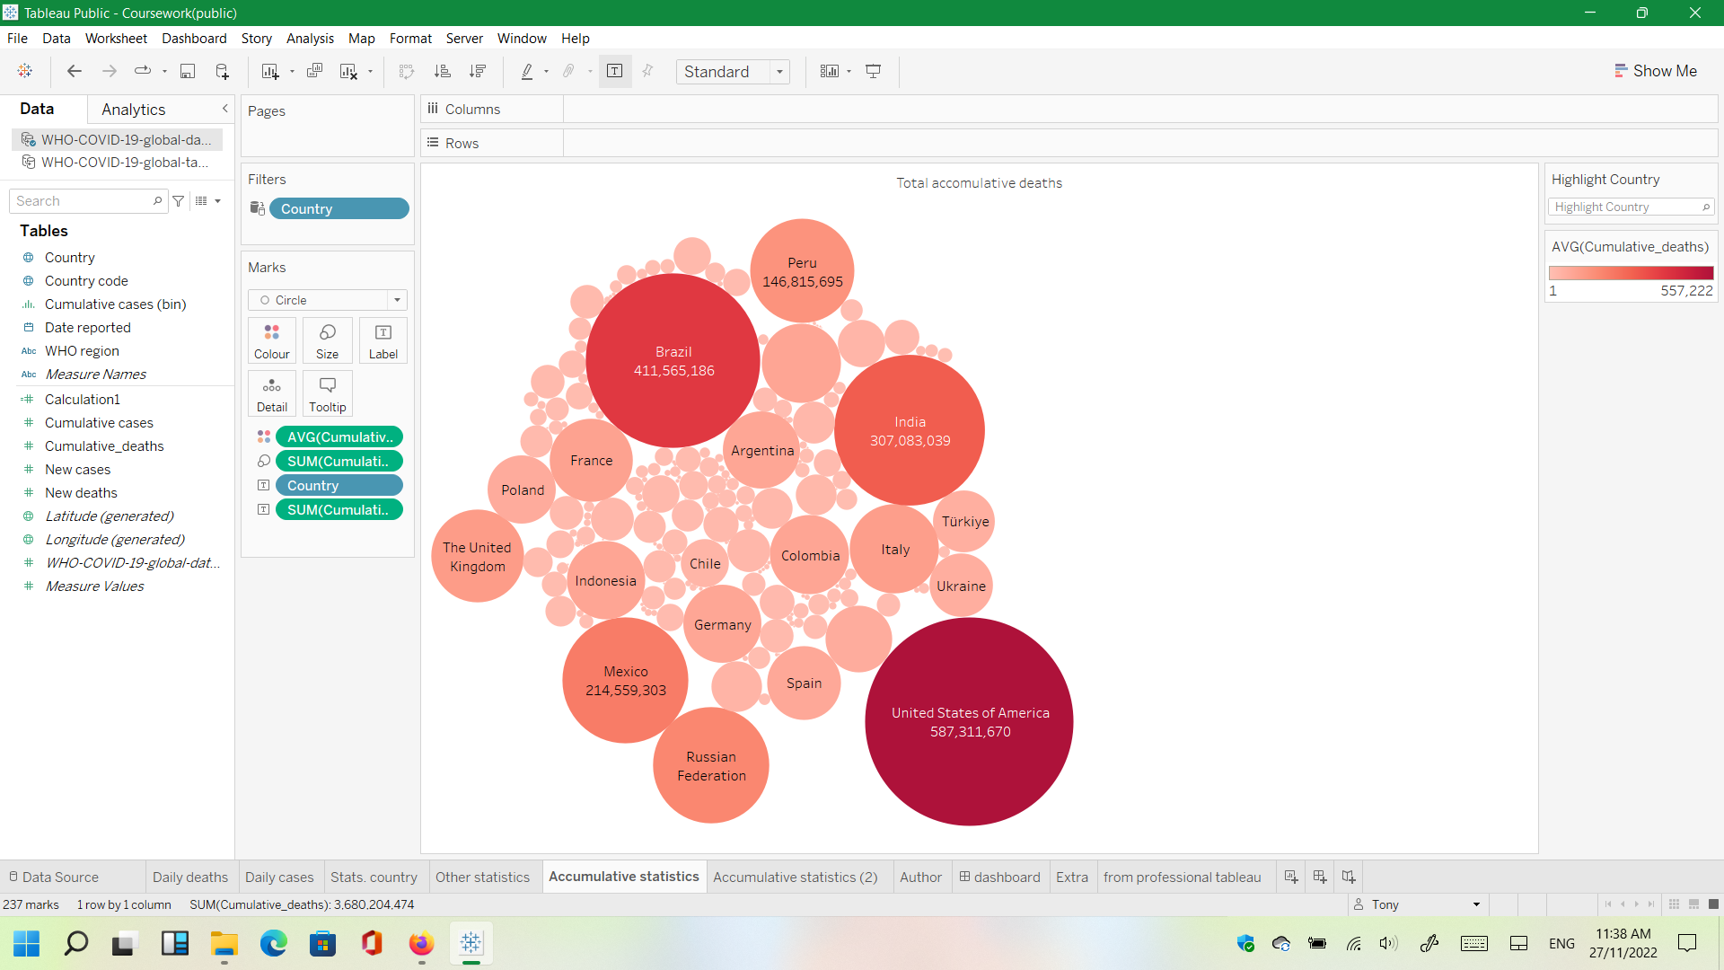

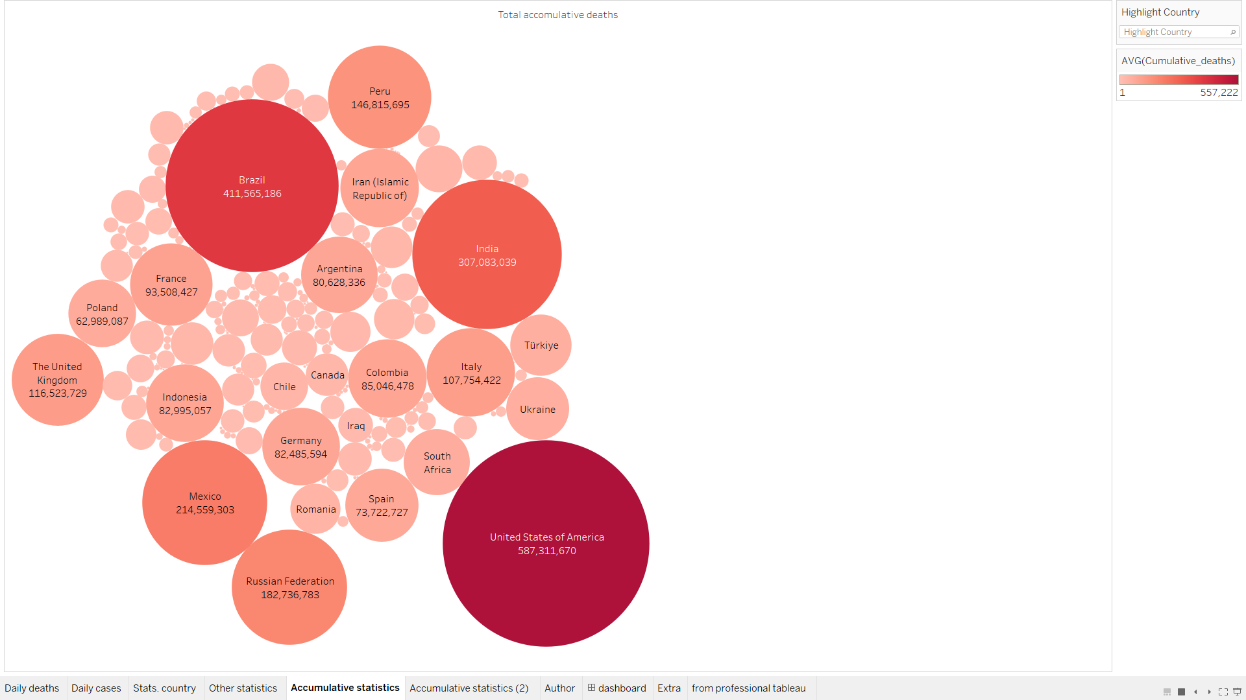

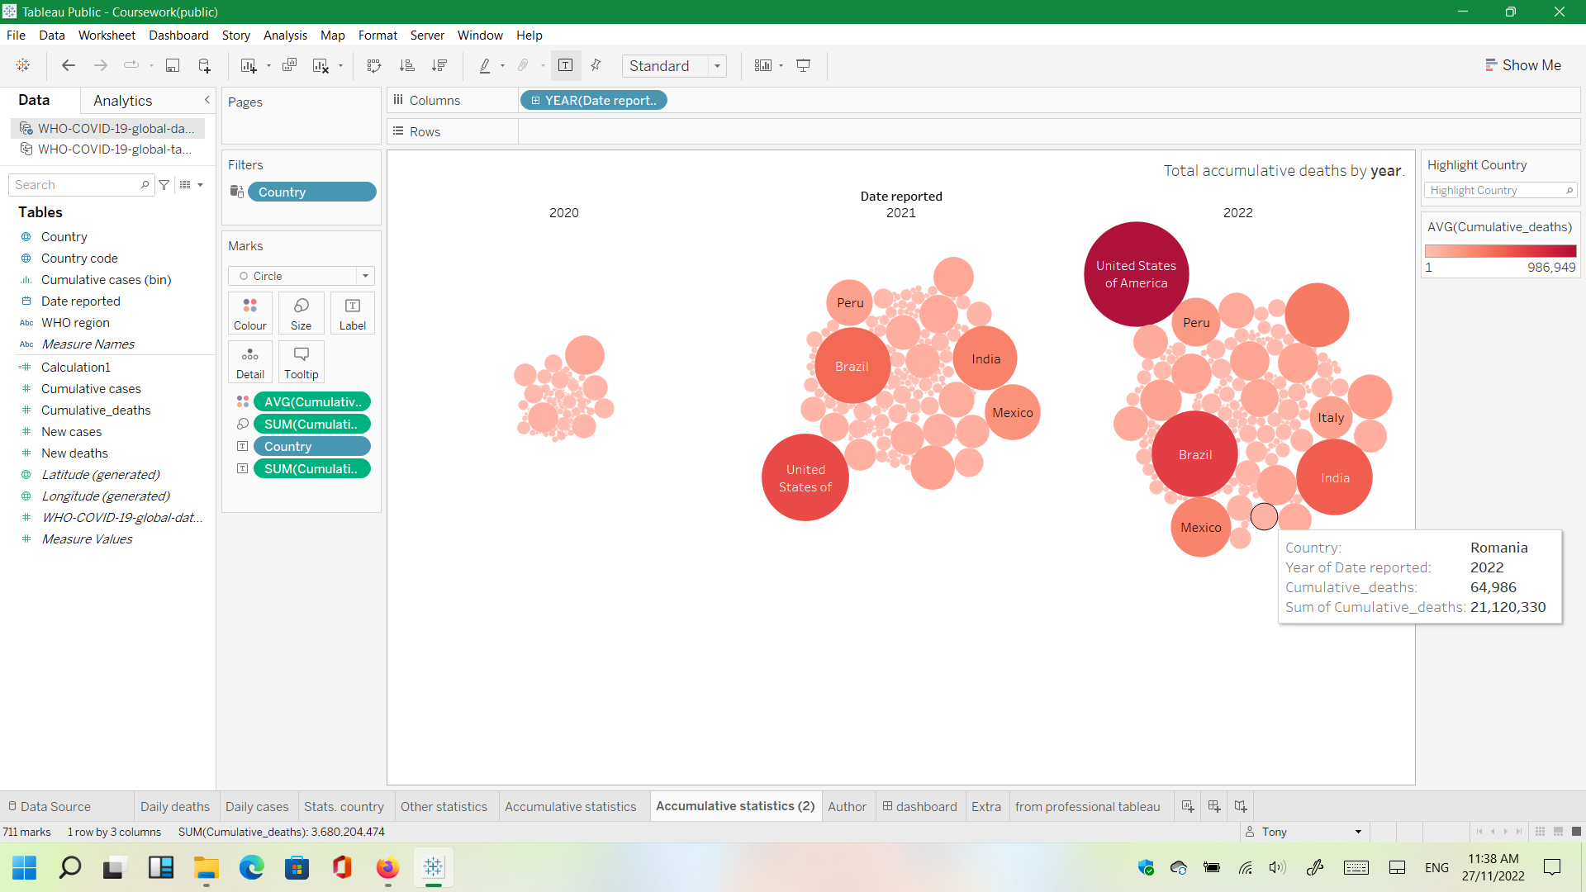

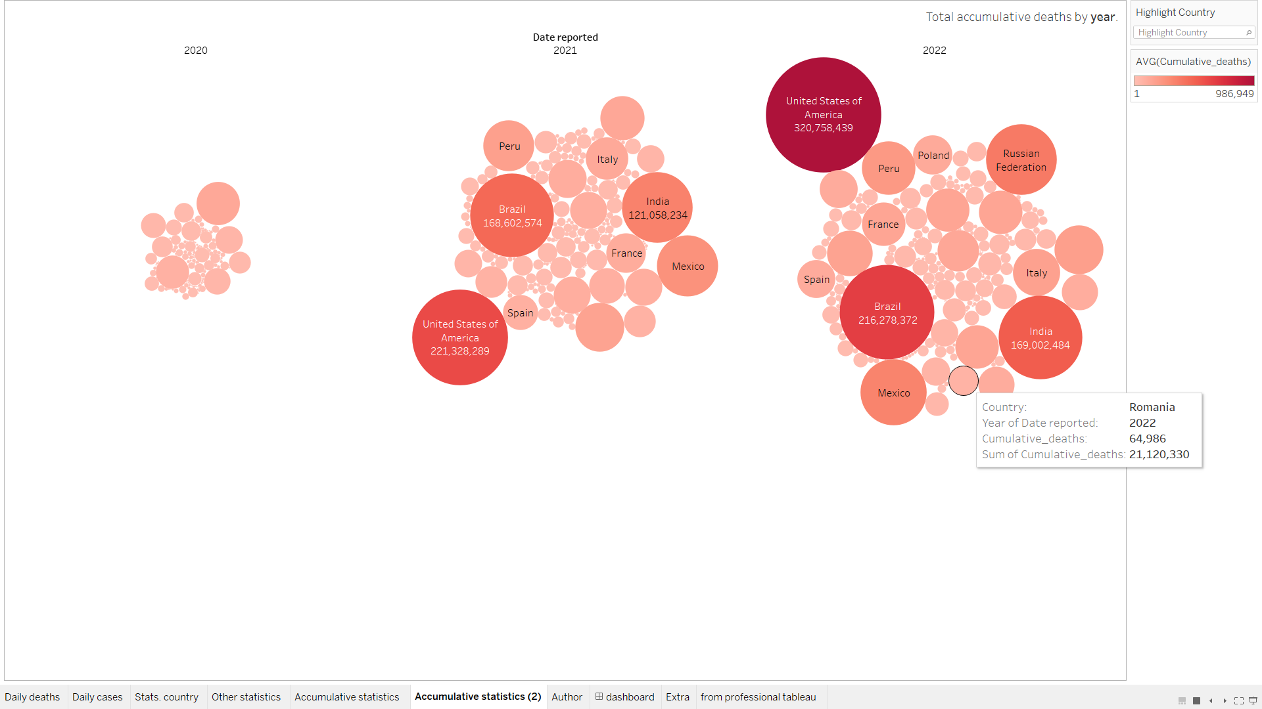

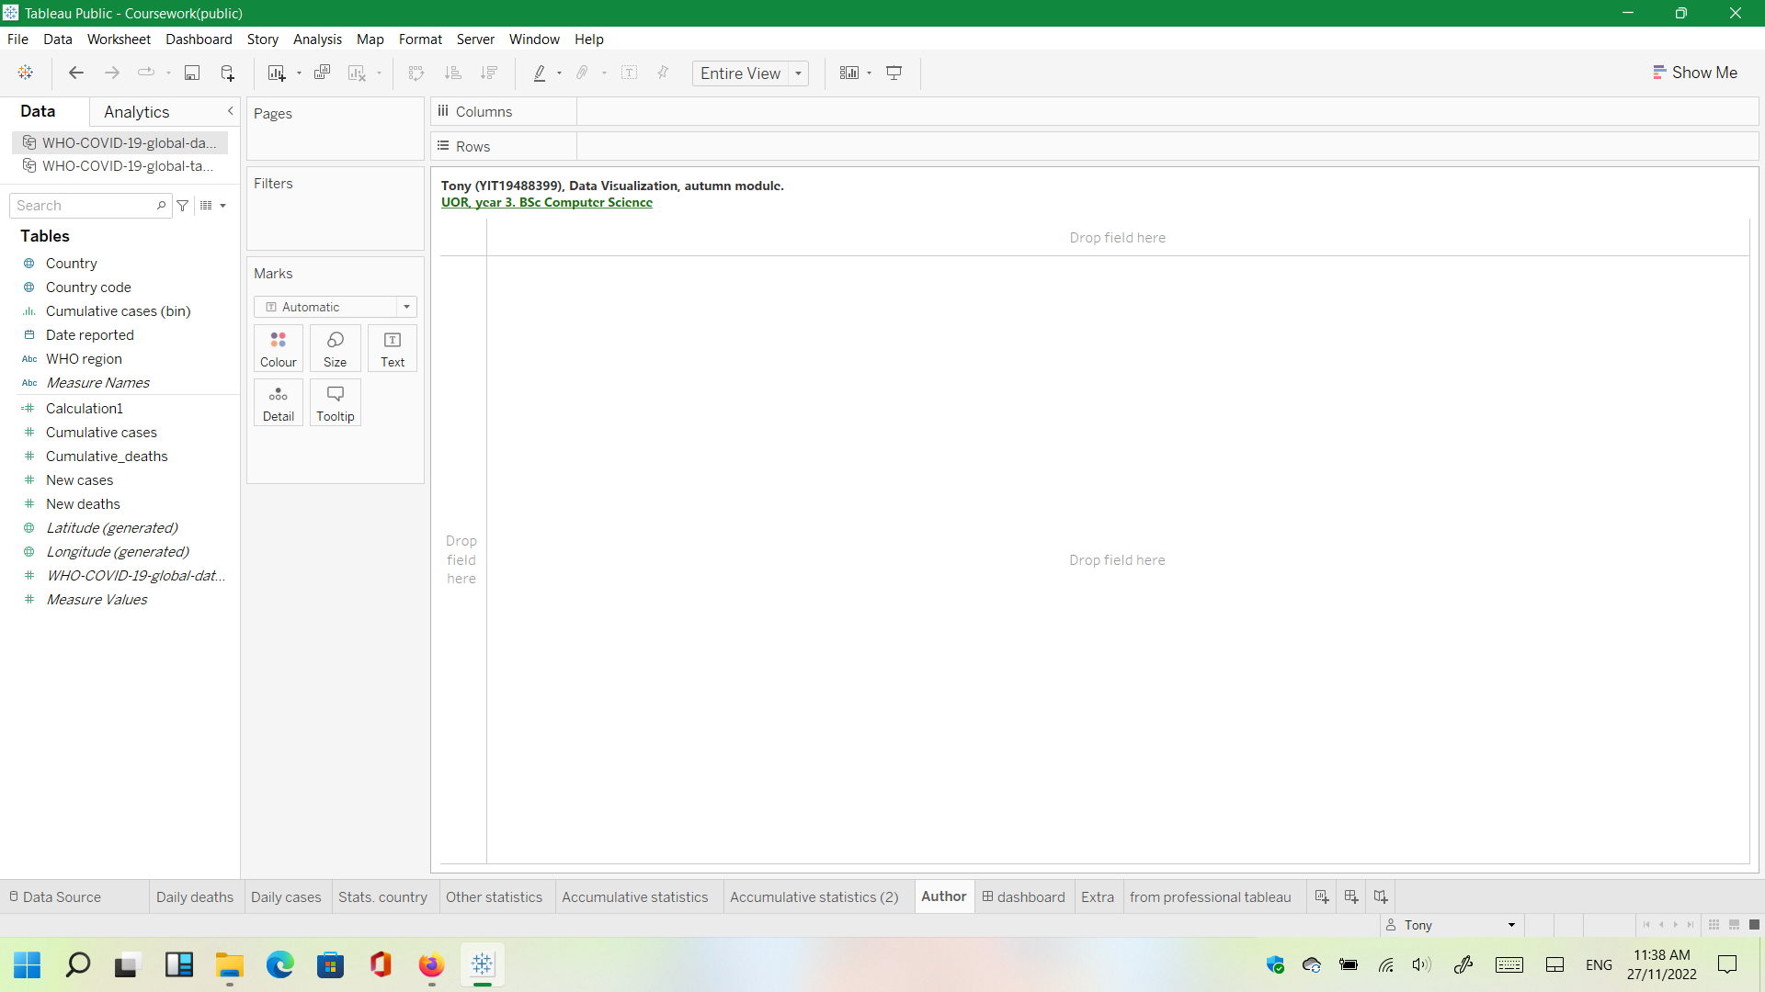

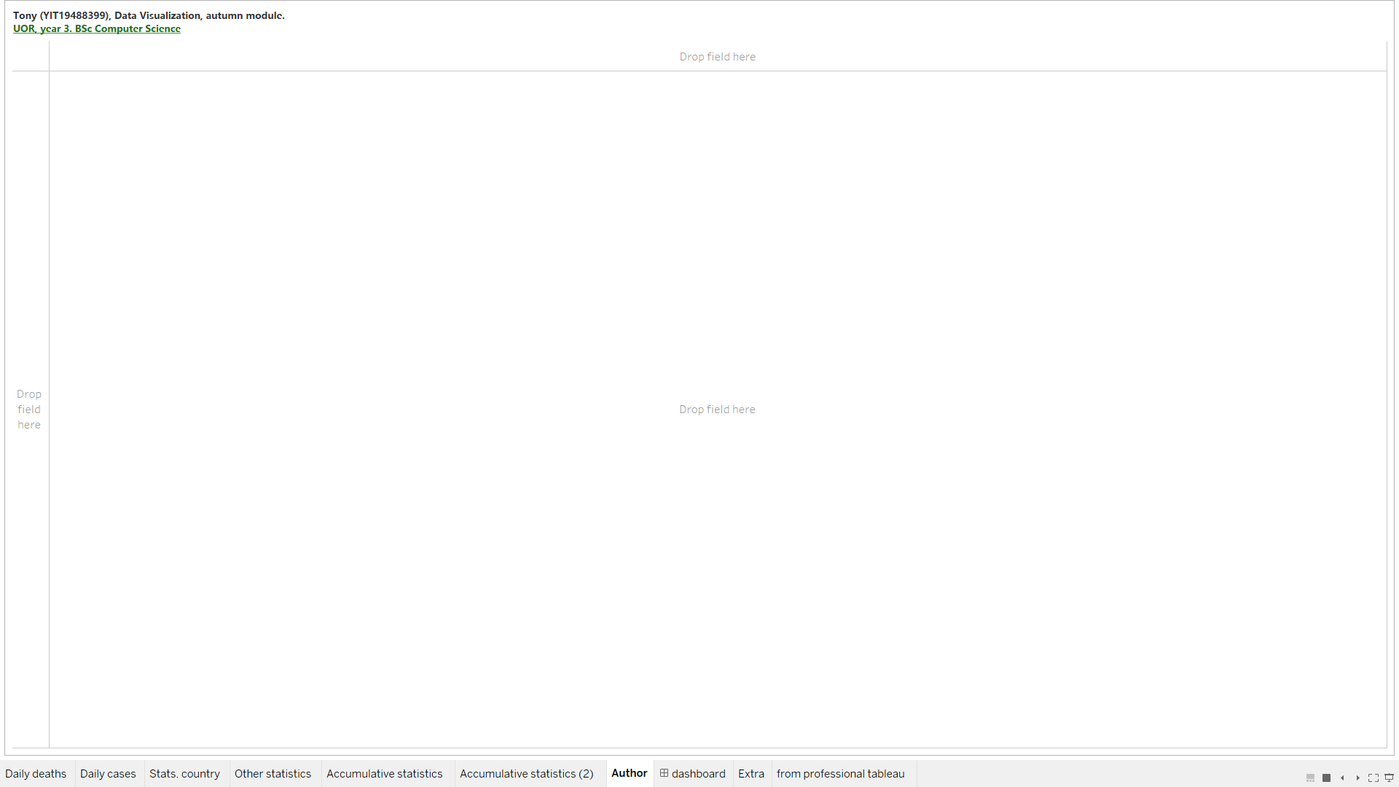

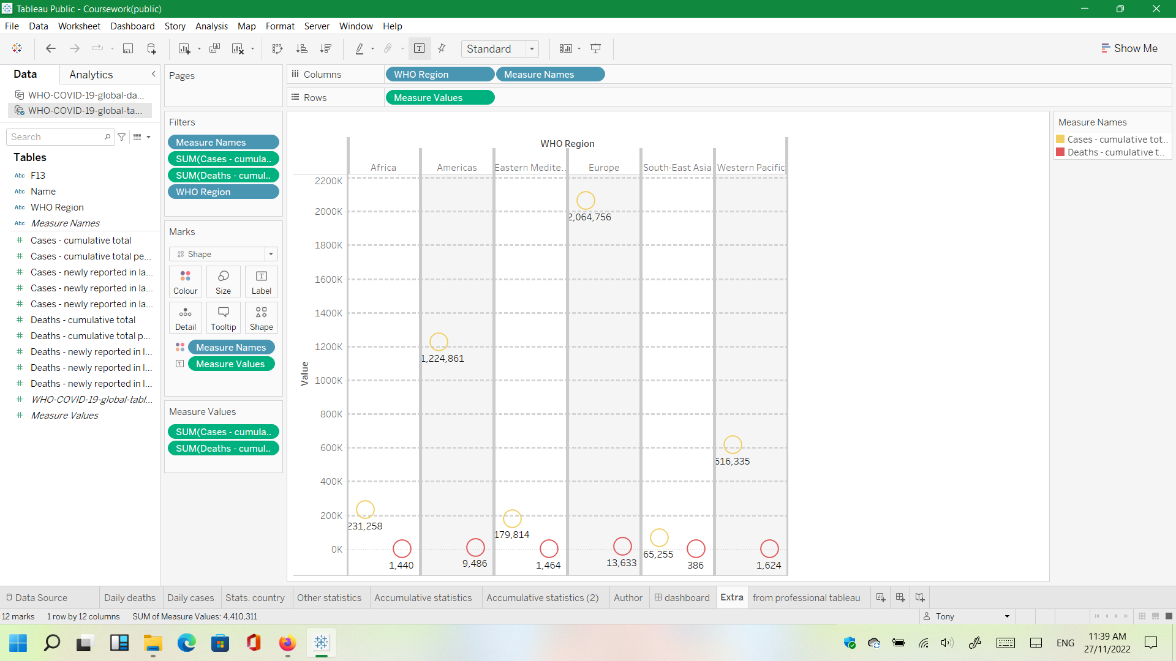

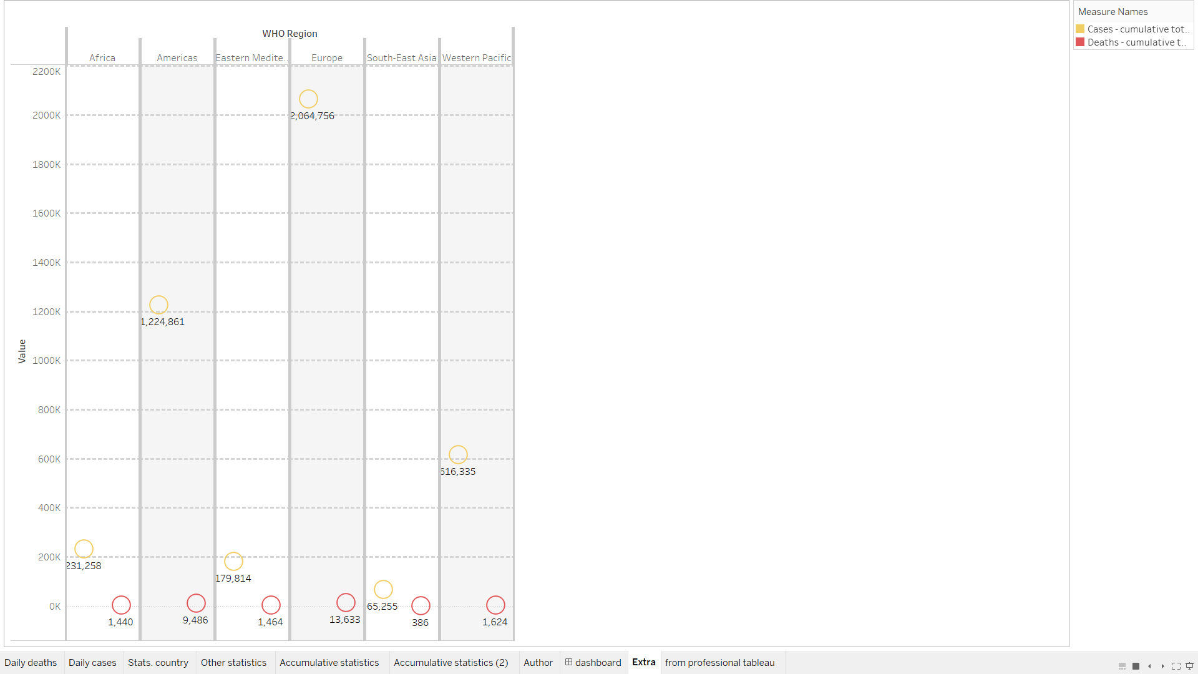

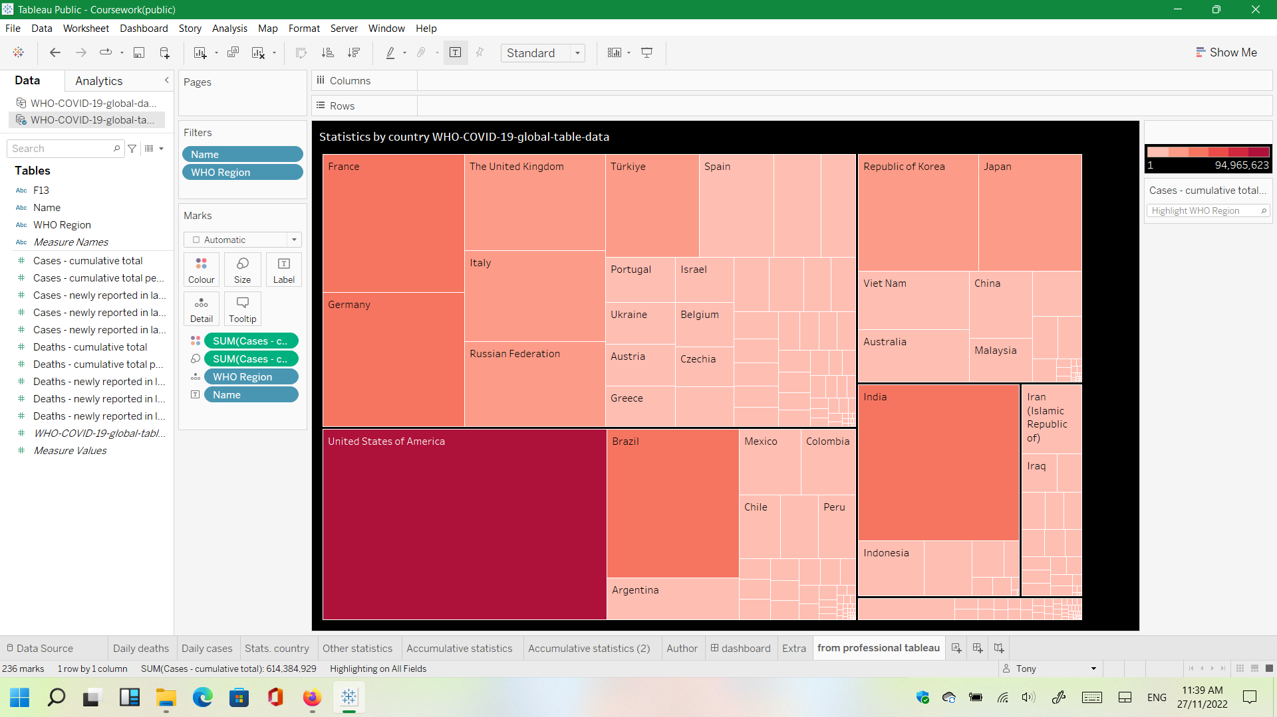

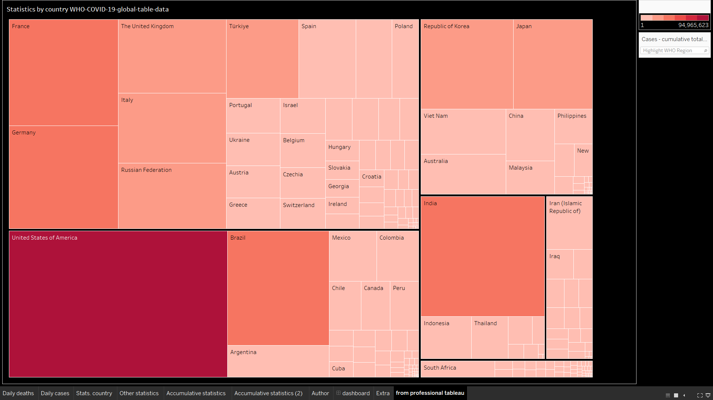

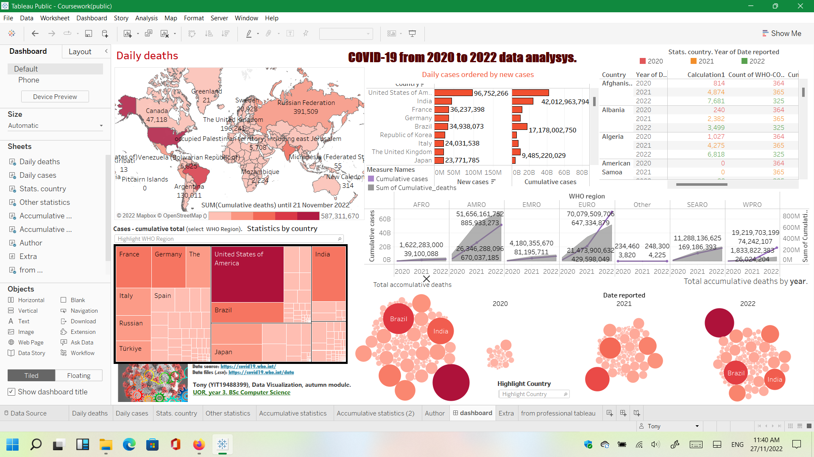

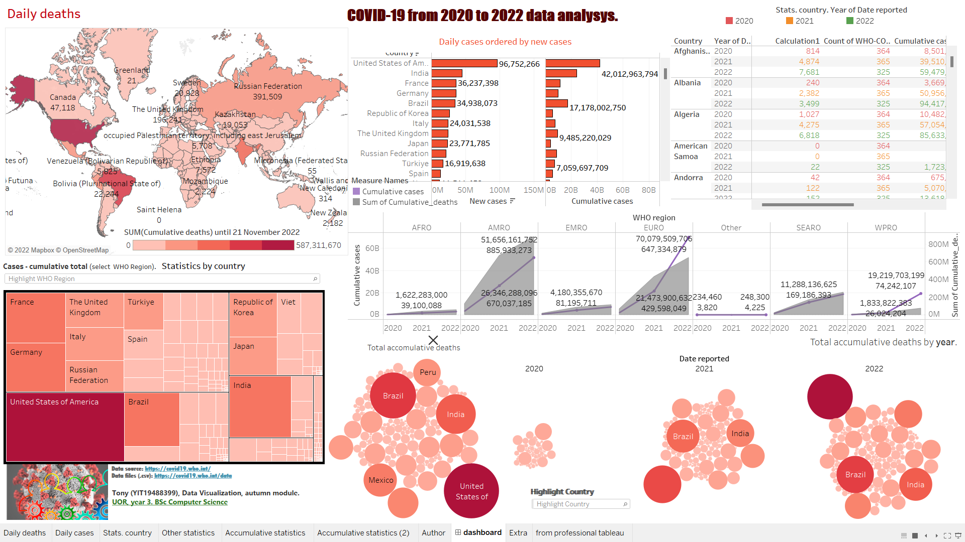

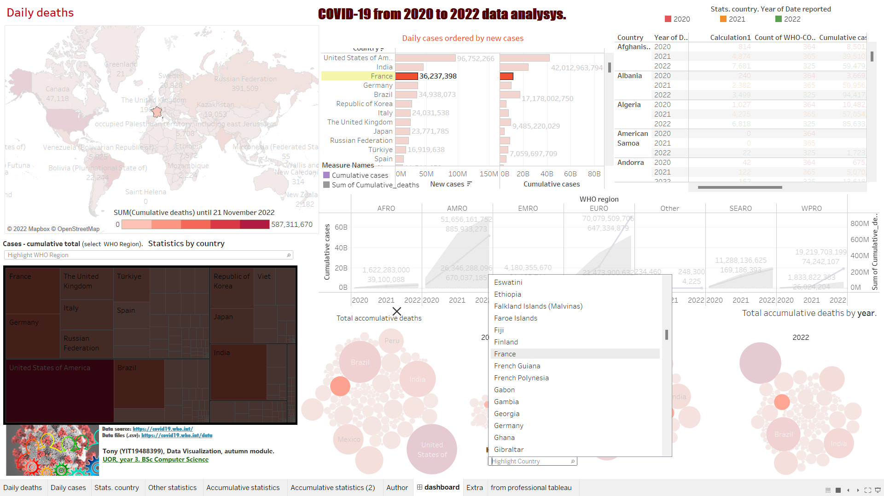

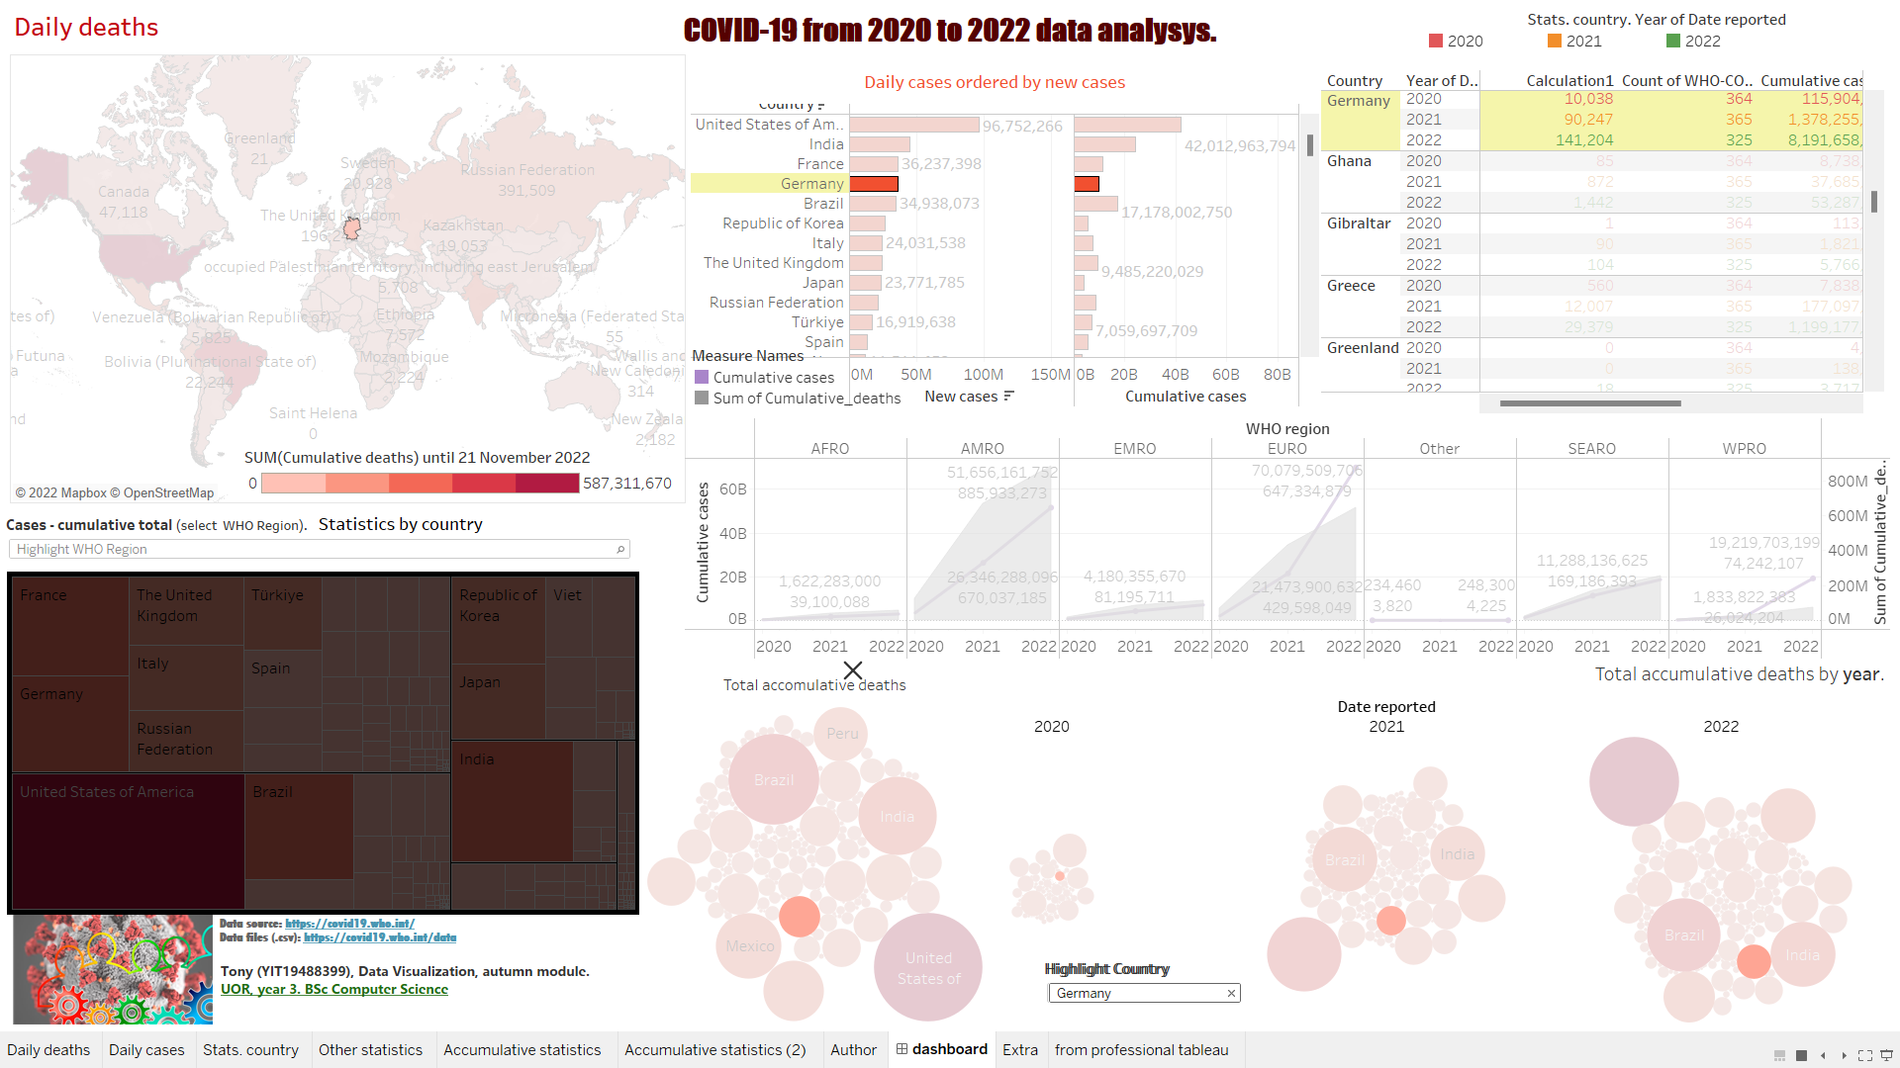

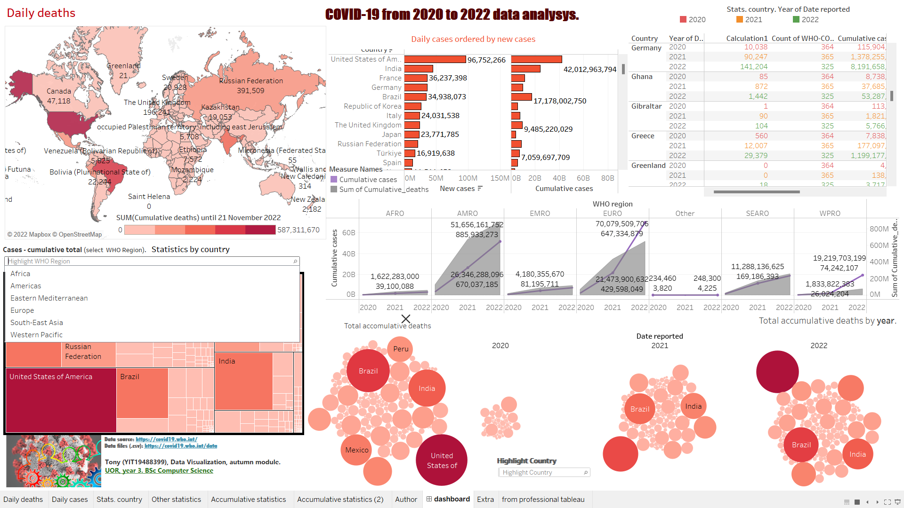

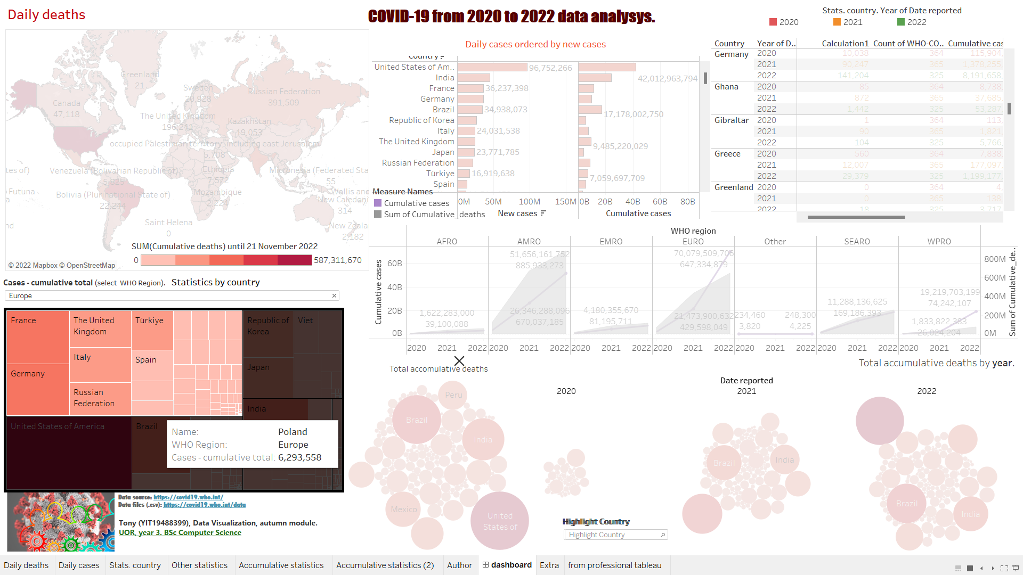

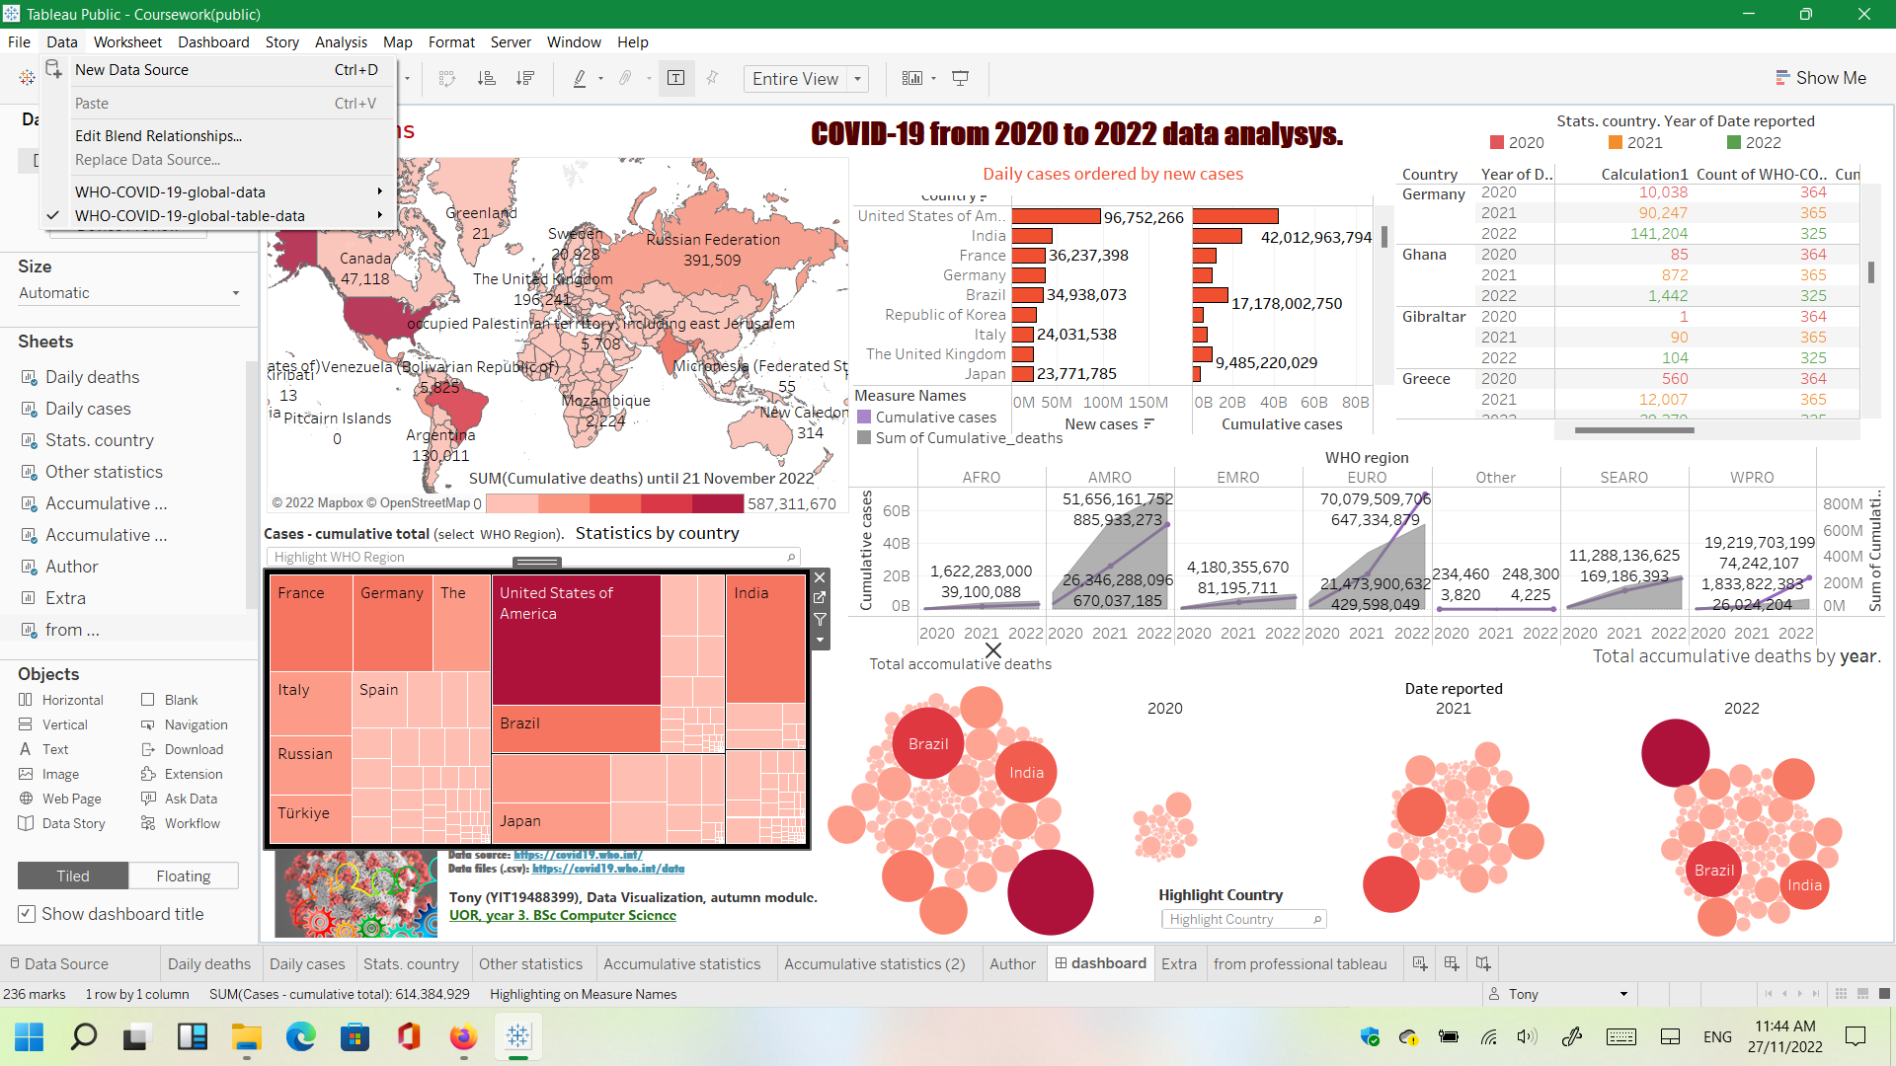

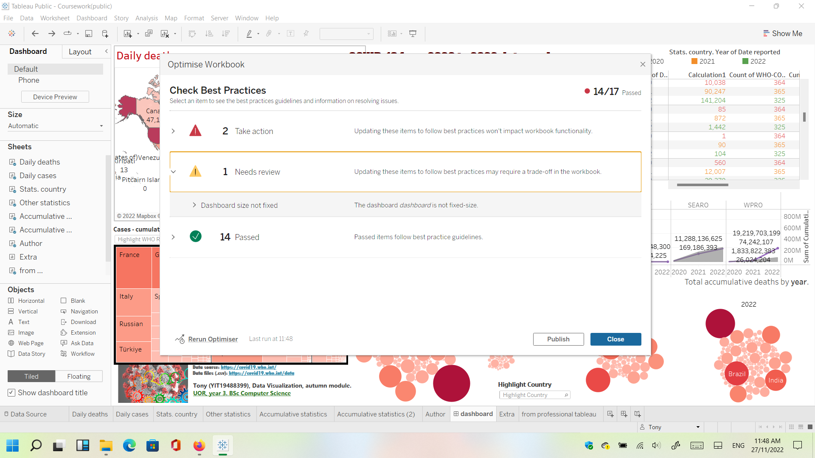

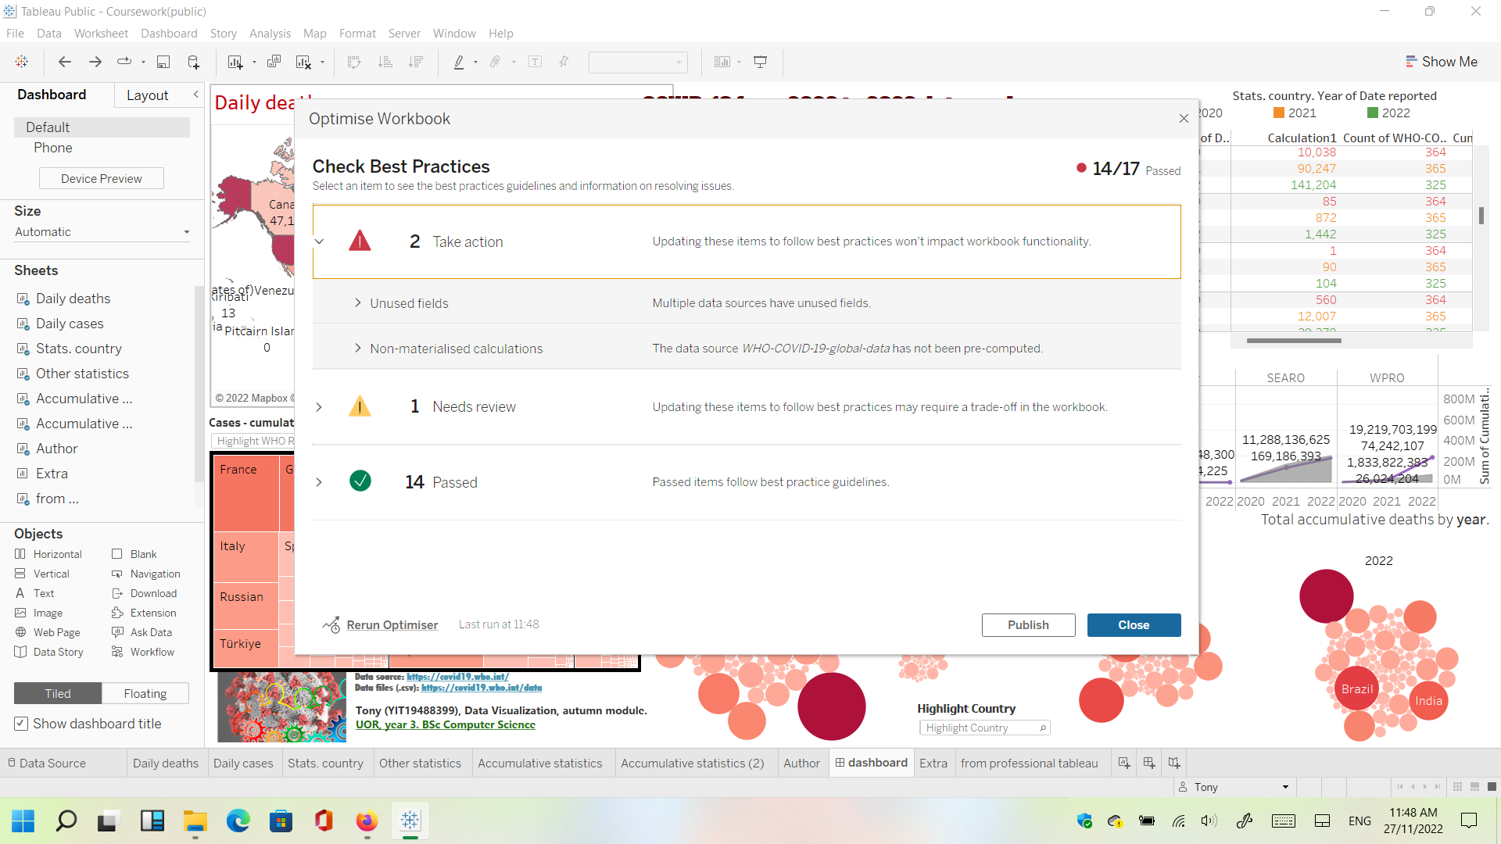

**Notes:**

Each worksheet has double screenshot, and the dashboard has meaningful visualizations to explain it. More screenshots with features are provided previously. And a video on YouTube explains better my dashboard. If necessary, I can comment my coursework in person with Lecturer (Mohammad Ahmad).

**Refinement task 1 (“Provide a short write-up (no more than 2 paragraphs) describing your plot design and display.”):**

1. The simplest possible plot. Because is the first plot, I preprocessed, analyzed, and cleaned the data. It has 2 pictures and the smallest one is very informative, but not aesthetically nicely presented because python was designed for numerical and statistical data tasks at the beginning (data analysis not same data visualization) [1].

I use blue color for vaccination and red to put attention to top countries with more brands. Text inside is black to show seriousness and standardization.

1. More advance bar chart because has 2 plots and uses 2 different colors. 11 countries I think is okay but can de more if like. Countries are NOT the same for both plots, nevertheless coincidences is/are possible. Blue background because plot is about vaccines and WHO used a lot of blue color. Red and green is to show difference between analyses in respective plots (data visualization).
2. This plot uses bubbles, and it opens in a browser. Legend clarifies continents and these colors are by default. Each bubble represents one country and as bigger is the bubble/circle, more deaths accumulate the country in question. It opens on a browser and this is the default for each user/machine (can be different browser and maybe slightly modifications are visible). I used Firefox.

This is the first plot with global data table dataset (NOT vaccinations dataset).

1. Same information as in figure 3 but analyzing ALL the countries in the planet in one single figure in one plot. The pie chart shows 2 information but only percentages are visible in the plot. Put mouse in the pie chart to see hidden information that will pop up.

Colors are by default and the plot opens again in a web browser. Legend is very useful to speed understanding.

1. This is dynamic plot because it changes day by day. Even the data source is different from provided in coursework. The period is some years, and the animation shows the advance of the coronavirus in the planet. Plot opens in web browser and only requires press play bottom at the bottom left by the public. Visualizations take about a minute to be completed.

Red is adequate, but green is not. Although this green color shows clear and obvious difference (contrast). The substitute of the green color could be black, but this color is better to avoid when health is the theme (black = death).

**Flaws in task 2 (Tableau Public):**

Tree map about continents is not synchronized with the dashboard. When selecting a country from this tree map, dashboard doesn’t work as expected. The same behavior happens when selecting country or continent in other part of the dashboard (NOT tree map), the tree map on the dashboard is not updating.

The conclusion is that Tableau is Business oriented and is not for “rocket science” analysis/studies/investigations. This behavior could be avoided if dashboard was designed with code like python, but this task will be much more tedious and complicated.

Summary: Tableau is good but can be improved and developed to analyze two datasets at the same time.

**References:**

[1] ‘best programming language for data visualization’. best programming language for data visualization

**Tableau Public own workspace:** [**https://public.tableau.com/app/profile/tony6278**](https://public.tableau.com/app/profile/tony6278)

**Tableau Public dashboard direct link for task 2:** [**https://public.tableau.com/app/profile/tony6278/viz/Courseworkpublic/dashboard**](https://public.tableau.com/app/profile/tony6278/viz/Courseworkpublic/dashboard)

**YouTube video for Dashboard:** [**https://youtu.be/ceYehmEPF8k**](https://youtu.be/ceYehmEPF8k)

**#END#**